Contact Information

Prinu.384748@2freemail.com

Skills
Automation Robot Operation Control panel wiring

Sensors, limit switch, timers and contactors

PLC programming

Fixture & SPM machine development

Maintenance & trouble shooting of SPM machines

Pneumatics, hydraulics& Electro pneumatics

Soldering,welding,drilling, lathe operation

Preventive maintenance Documentation Spare maintenance

In-house development of automated SPM machines

SAP

Prinu
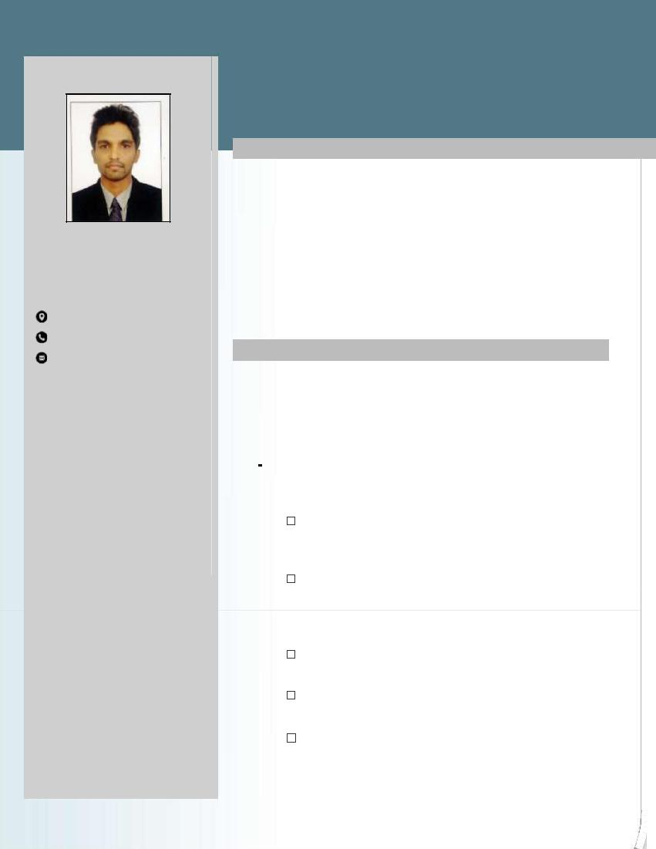

Automation Engineer

Summary

Diploma in Mechatronics , Automation Engineer, Production Engineering Department (PED),

Summary:

Dynamic professional with Diploma in Mechatronics from Nettur Technical Training Foundation (NTTF), Thalassery, having over 2 years of Experience in TVS Company as Junior Production

Engineer in Automation Field.

Work Experience

1.Company Name: TVS Sundaram Auto Components LTD - CHENNAI

Start date: 03/09/15

End date:03/09/16

- Company Name: TVS Sundaram Auto Components LTD - HOSUR

Start date:06/09/16 End date:30/11/17

To develop different Automated Machines, SPM, that reduces man power, improves cycle time and increase production

Supervising the employees about the working. Trouble shooting and maintenance of different automated machines and Robots

Maintaining records, check list and documents of SPM,Robots and other machines.

Taking important measures and action for customer complaints.

To communicate and develop new type of automated Machines to employees and to complete the project within the lead time.

ACHEIVEMENTS
• Won the best SIT award for the Financial year 2017-2018

PROJECTS

BA Nozzle defroster 4 point welding Fixture

This project is used to weld the part using ultrasonic welding machine Automatically. 

GS Outer retainer assembly Fixture

This Fixture is used to assemble the child part using pneumatic cylinders Automatically. 
Assembly area monitoring System using PLC

This project is used to monitor the daily production, rejection quantity in the assembly area 
The fixture mainly contains a PLC to receive the the outputs from each fixture and an HMI to display the outputs from the PLC. 

Remote controlled Roof door

This project is used to control roof door using remote. The opening and closing of door is controlled by pneumatic cylinders 

Anabond curing System

This project is to cure Anabond applied on the part (4 hours) 

Once the trolley enters the station exit door will be closed for 4 hours and after 4 hours the exit door will be opened. 
The Anabond is cured by using cooling fans and the timing operation is controlled by PLC. 
Bosch Leak testing Machine

This project is used to check the leak test of Bosch fuel filter. The Fixture applies 10 bar pressure on the part and check for leakage using pressure sensors. The OK part is engraved with date and time the rejection part gets rejected without engraving.
Finger print operated door using Adruino Finger print sensor 

This project is used to unlock the door using finger print .this project helps the unauthorized access to the room 

 | P E R S O N A L |  | P R O F I L E :
 | Date of Birth |  | : 10/08/1994
 | Sex |  | : MALE
 | Marital Status |  | : SINGLE
 | Nationality |  | : INDIAN
 | Religion |  | : HINDU
Languages Known
 |  |  | : ENGLISH, MALAYALAM,TAMIL,HINDI
 | To Speak
 | To Read |  | : ENGLISH, HINDI, MALAYALAM
 | To Write |  | : ENGLISH, HINDI, MALAYALAM

DECLARATION

I

I consider myself familiar with MECHATRONICS ASPECTS and I am also confident of my ability to work in a team.

I hereby declare that the information furnished above is true to the best of my knowledge.

