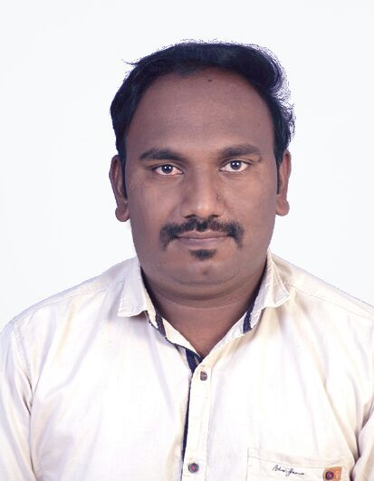

MUKESH

Email- mukesh.384752@2freemail.com

CAREER OBJECTIVE

To work in a firm with a professional work driven environment, where I can utilize and apply my knowledge and skills which would enable me to grow while fulfilling organizational goals.

BASIC ACADEMICS QUALIFICATIONS

Qualification | Board/University | Year | Percentage
Diploma  (Computer Science Engineering) | “K L E Polytechnic College”  Affiliated to D T E, Bangalore | 2013 | Appeared
SSC | Shantiniketan Sec & High Sec High School | 2010 | 83.64%

IT PROFICIENCY

Certificate of achievement in IT Knowledge.

Certificate of achievement in Hardware (A+) & Networking (N+)

Microsoft Office Word, Microsoft Office Excel, Microsoft Office Power Point

Mobile Repairing Course

INTERPERSONAL SKILL

Ability to rapidly build relationship and set up trust.

Self-confidence

Can absorb quickly and contribute productively.

Ability to cope up with different situations.

WORK EXPERIENCE

Worked as a Technical Support in N.I.C.E Institute (12-Oct-2014 to 08-Jan-2016 – 1 Year 4 Months)

MY Computer Shop worked as Service in Computer and Mobile

(February - 2016 to March 2017- 1Year 4 Months) Self-employed dealing with hardware and networking operations like OS installation, troubleshooting, LAN connections, networking, CCTV installation, software installation, assembling and dissembling laptop and desktops, on mother board connections, bios setup, printer installation, printer connection on network, sharing etc.

Presently working with DHL Supply Chain as Desktop Engineer since 19th April 2018.

PERSONAL DETAILS

Date of Birth : 13th October 1993
Nationality : Indian
Languages Known : English, Hindi, Kannada and Marathi

DECLARATION

I hereby declare that the above mentioned information is true and best of my knowledge. I’m assuring you of sincerity & dedication to learn.

