wasim

Email: wasim.384795@2freemail.com
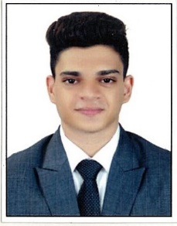

Professional Objective
To seize an opportunity to utilize myskills in the organization that offers professional growth while being resourceful, innovative and flexible and hence contribute value to the growth of any Organization.

- Fluent communication skills
- Organized and adaptable
- Motivational and Leadership Qualities
- Quick and Smart Learner
- Dedicated employee with high integrity and strong work ethic

Educational Qualification

- Diploma in aviation -Frankfinn institute of Air Hostess Training, Mumbai, Maharashtra, India (2016-2017)
- Training in Electronics and Telecom Eng. (2013-2016)
- Higher School Secondary Certificate - National Jr. College, Dapoli, Maharashtra, India (2011-2013)
- Secondary School Certificate- U.A.Dalvi English Medium Dapoli, Maharashtra, India (2000-2010)

Professional Experience

The J Café: Store Manager& Administrator
Duration: June 2016 – Aug 2018
Job Responsibilities:
- Managing the assets of the store
- Order preparation
- Suggestive selling preference by assisting customers
- Promoting store cards or special offers
- Aiding customers with information on pricing and product availability
- Maintain proper loss prevention standards, reviewing cash handling procedures, deposits and safe procedures
- Ensures proper team member coverage, scheduling according to the needs of business
- Handling and resolving customer complaints
- Ensure that all team members provide customers with efficient, friendly, superior service on a consistent basis

Achievements & Certifications

- Government of India Ministry of Skill Development & Entrepreneurship for Front Office Associate.

Personal Details

Age: 21
Date of Birth: 3rd Jan 1996
Marital Status: Single
Nationality: Indian (Indian Passport)
Languages known: English, Marathi, Hindi, Urdu, (Reading, Writing, Speaking), Basic Arabic

