Sadiq

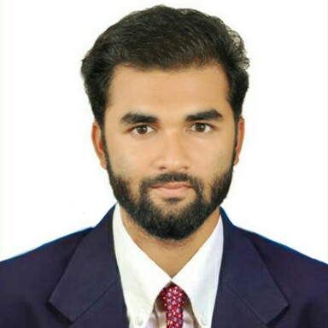 | E-mail: sadiq.384878@2freemail.com

Career Objective
To work for an organization which provides me the opportunity to improve my skills and allows growth along with the organization objective.

Profile Summary
- An enthusiastic fresher with highly motivated and leadership skills having bachelors of engineering degree in Electronics & Instrumentation.
- Expert in implementation of each step of project.
- Eager to learn new technologies and methodologies.
- Always willing to innovate the new things, which can improve the existing technology.

Academic Qualification

Degree /Qualification | Institute | Board /  University | Year | Aggregate % / CGPA
B. Tech,  Electronics & Instrumentation | Institute for Technical Education and Research | S’O’A University | 2018 | 7.6
+2 Science | Dibya jyoti  science college | CHSE | 2014 | 50
10th (Board) | St. Xavier’s High School | ICSE | 2012 | 65

Technical Skills
- PLC Programming
- SCADA
- NI Multisim
- Matlab Programming
- Team Leadership
- Project Management
- PCB design
- Embedded Systems
- Industrial Automation

Trainings

Name of Institute / Organization | Project Title | Duration
TATA MOTORSLTD. Jamshedpur. | 'Conversion of Relay logic to PLC ladder logic' of oil filling Machine in Gear box section | 30 days

Accolades
- Achieved 2nd position in ITER College Electronics Workshop for making Laser Security System.

Extra-Curricular
- Designing Electronic Projects
- Web searching (SEO)
- Writing content article’s for blogs

Personal Details
- Date of Birth : 06/03/1997
- Gender : Male
- Marital Status : Unmarried
- Blood Group : B+
- Languages known : English, Hindi, Arabic.
- Interests : Research in upcoming Technologies

Declaration
I hereby, declare that the information furnished above is true to the best of my knowledge.

