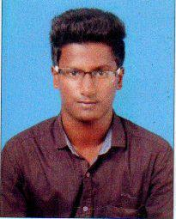
RESUME

MOHAMMED
Email: mohammed.384891@2freemail.com

CAREER OBJECTIVE:

To be associated with progressive that gives scope to my knowledge and skills in area as of development of application and to be part of the team that dynamically works forward to growth organization.

EDUCATIONAL QUALIFICATION:

CLASS\CO | NAME OF THE | BOARD | MARKS | YEAR OF PASSING
URSE | INSTITUTION | OF
 |  | STUDY
 | MV Government Higher
10TH | Sec School Karaikudi. | State | 80% | 2013
 |  | Board
 | St.Joseph Polytechnic
DCE | College Thirumayam. | Dote | 70% | 2016

EXPERIENCE
Worked at Site Supervisor of Construction (20 month)

COMPUTER KNOWLEDGE:
Autocad, Ms office, Ms Excel, Ms Word, Ms power point

PERSONAL DETAILS:

Name | : | MOHAMMED
Date of Birth | : | 02-10-1998
Gender |  | : | Male
Nationality | : | Indian
Reliogion | : | Muslim
Languages Known | : | English,Tamil

DECLARATION

I hereby resolve that the details furnished are true the best of my knowledge and belief.

Place:

Date: Yours truly

(MOHAMMED)

