Soumya
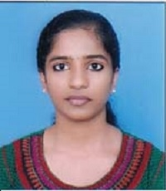

Email : soumya.384893@2freemail.com

____________________________________________________________________________________
Objective:
To work in a respected company where I can utilize my skills towards the development, contributing to growth of the organization and to continuously upgrade my knowledge and skills.

Educational Qualifications:

Engineering in Computer Science completed from University of Kerala, INDIA on June 2018 with CGPA of 8.23 out of 10.0 (Distinction).
12th completed from Central Board of Secondary Education, INDIA.
- 10th completed from Central Board of Secondary Education, INDIA.

Personal details:

Nationality : Indian
Date of Birth : The 21st day of October, 1996

Languages Known : English, Hindi, Malayalam (Speak, Read & Write skills)

Personal skills

- Presentations and public speaking.
- Hard working and sincere.
- Ability to handle people in an efficient way.
- Determined and disciplined.
- Willingness to learn and obtain new skills.

*****

(2)

