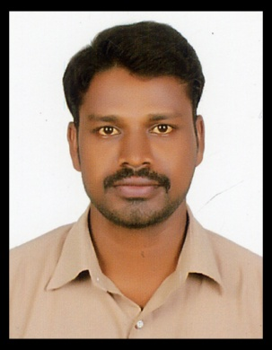
RESUME

KONKI
Email: konki384895@2freemail.com

Seeking a quality environment where my knowledge and experience can be shared and enriched. Looking for a responsible position where I can in a challenging environment.

- S.S.C FORM : GOVT HIGHT SCHOOL. OLBANSWADA (2002) NIZAMABAD.

- INTERMEDIATE FORM : BHARATHA RATNA JUNIOR COLLEGE (2004) C.E.C GROUP BANSWADA , NIZAMABAD.
- DEGREE FORM: GOVT DEGREE COLLEGE BICHKUNDA.NIZAMABAD. OSMANIA UNIVERSITY. (B.A. HEP) 2007.
- P.G FORM : M.A HISTORY OPEN UNIVERSITY (2009).O.U NIZAMABAD.IN DISTANCE

- CREDITE ASISTANT IN SIDDIPET DIST: MEDAK. 18-08-2009 to 17-08-2010
- SPANDANA SPHOORTY MICRO FINANCIAL LTD: BRANCH MANAGER . KANTESHWER ROAD NIZAMABAD .DIST: NIZAMABAD. VARUN MOTORS PVT LTD BANSWADA INCHARGE AND ACCOUNTS BANSWADA
Dist : NIZAMABAD .01-04-2015 to 31-12-2016.
- HDB FINANCIAL PVT LTD .RURAL SALES OFFICER IN BODHAN NIZAMABAD :DIST HDFC BANK
23-05-2017 TO 12-06-2018

Positive mental attitude.

- Logical and Analytical skills
- Net Browsing
- Maintenance for the staff.
- ACCOUNTS & DAILY MONTHLY REPORTS

Gender : Male
Date of Birth : 19-06-1986
Marital Status : MARRIED
Nationality : INDIAN
Languages known : ENGLISH, HINDI & TELUGU

S

I hereby declare that the information furnished above is true and correct to the best of my knowledge.

KONKI
Place:
Date:

