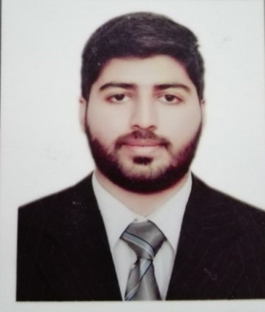
Aqeel
Curriculum Vitae

Personal Details

Date of Birth : 10-October-1994
Email-id : aqeel.384913@2freemail.com
Gender : Male
Nationality : Pakistani
Religion : Islam
City : Dubai
Language : English, Urdu, Punjabi
Marital Status : Single

Education

Bachelor: 2013-2017
BS-Software Engineering
University of Management and Technology Sialkot, Pakistan
Bachelor of Science in Software Engineering
Intermediate: 2010-2012
F.S.C (Pre Engineering)
Leadership College Sialkot, Pakistan
Matriculation: 2008-2010
Crescent Model High School Sialkot, Pakistan
Matric (Science)
IT Projects:
Website for vehicle repair shop (Jan 2017- May 2017)
Develop a website for Vehicle Repair Shop to maintain the employee record, spare parts record, customer record, bill record and also customer can take booking time for service.

Work Experience

1 year Experience as a School Science Teacher (May 2015 - June 2016)
1 year Experience as a Web Developer using HTML and CSS at Micro Tech Software Sialkot, Pakistan. (July 2016 - June 2017)
6 months Experience as a Junior Network Engineer(5th Jul 2017 - 10TH JAN 2018)
6 Months Experience as an Assistance (01ST FEB 2018 - 25th Aug 2018)

Skills
Technical Skills

- HTML5
- CSS
- C++
- Microsoft word, Excel, PowerPoint
- Visual Studio
- Communication typing speed using MS Office

