Sujayalal 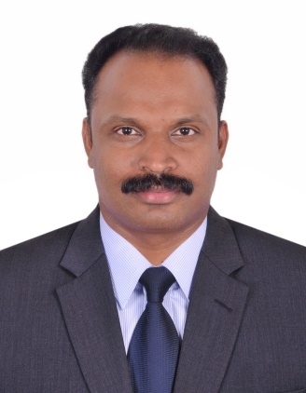
Email: Sujayalal384917@2freemail.com
~ SENIOR FINANCE PROFESSIONAL ~
Objective

To find a fulfilling position where I can apply my skills and knowledge.

Personal statement

A highly motivated and driven finance manager with ten years' experience in top level business environments. A broad knowledge of a wide range of financial practices, including credit control, budget handling and forecasting. An excellent communicator with a can-do approach to problem solving and resolution. Extremely meticulous with an eye for detail and positive outlook in often complex financial landscapes.
Core skills

- Strong financial and management skills
- Excellent communication and presentation skills
- Proven financial planner
- Problem-solving skills and initiative
- Negotiation skills and the ability to influence others.
- Strong attention to details and an investigative nature
- Good time management skills and the ability to prioritise
- Well versed with Windows Office Tools, Tally 9 ERP, Quick book etc.
- Good IT skills.
Employment History

1. Finance Manager
(February 2015 – Present).
Duties
- Monitor the day-to-day financial operations within the company, such as payroll, invoicing and other transactions.
- Oversee financial department employees, including financial assistants and accountants.
- Track the company’s financial status and performance to identify areas for potential improvement.
- Seek Out methods for minimising financial risk to the company
- Provide insightful information and expectations to senior executives to aid in long-term and short-term decision making
- Review financial data and prepare monthly and annual reports
- Present financial reports to board members, stakeholders, executives and clients in formal meetings.
- Creating and working to financial growth plans
- Maximising performance of financial team
2. Senior Accountant –Al Khalijia Travel & Tourism Agency LLC, Dubai, UAE
(June 2012 – August 2014)
3. Senior Accountant-Al Noor Optical W.L.L, Manama, Kingdom of Bahrain
(August 2006 – September 2010)
Duties
- Prepare and records asset, liability, revenue and expenses entries by compiling and analysing account information
- Maintains and balances subsidiary accounts by verifying, allocating, posting, reconciling transactions, resolving discrepancies.
- Maintain general ledger by transferring subsidiary accounts, preparing a trial balance, reconciling entries.
- Summarizes financial status by collecting information, preparing balance sheet, profit and loss, and other statements.
- Produces payroll by initiating computer processing, printing checks. Completes external audit by analysing and scheduling general ledger accounts, providing information for auditors

Education

Kerala University, India
(2000 - 2003)
B com in Accounting and Finance
Including the following modules:
- Business management
- Advanced accounting
- Auditing
- Principles of Marketing
Personal Dossier

Date of Birth : 31.05.1983
Nationality : Indian
Marital Status : Married
Language Skills : English, Hindi & Malayalam
Driving License : UAE (Light vehicle-Manual License)

