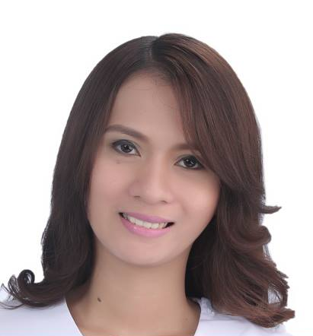
TAMAYO

Email Address: Tamayo.384925@2freemail.com

Professional Objective: To enhance the knowledge, skills and attitudes needed for a healthcare professional team who worked with precision and accuracy.
CAREER OBJECTIVE
Licensed Medical Laboratory Technologist, under Health Authority Abu Dhabi (HAAD), with a proficient clinical experience of 2 years in a routine laboratory setting.

Extensive experience in running both Biochemistry and Immuno-Serology Testing for clinical and medical patients. Trained to do troubleshooting and maintenance on certain laboratory equipments.

Computer literate: Microsoft Word, Microsoft Excel and Microsoft PowerPoint
fast learner,willing to train and be trained, shows great sense of responsibility in assigned tasks, can work under pressure, patient and hardworking and have good interpersonal relationship
However, I manage to work in different departments that convey in the laboratory which includes the following departments:
- Phlebotomy
- Coagulation
- Hematology
- Clinical Microscopy and Clinical Microbiology
- Blood bank
- Biochemistry/ Immunology and Serology.

WORK EXPERIENCE

Company Name: Pangasinan-Philippines
- Position: Medical Technologist
- Inclusive date of Employment: June 20, 2016 - present

Responsibilities:
- Collect samples of blood, urine and spinal fluid from patients and perform various laboratory tests depending upon the disease the patient is suffering from
- Perform all kinds of tests like microscopic tests, bacteriological tests and chemical tests to check the composition of the biological samples in the laboratories
- Analyze the tests that have been performed and provide relevant results that may pertain in diagnosis, prevention, and treatment of diseases
- Check the blood group and blood type and help in successful blood transfusion for patients suffering from severe diseases
- Check and look after the maintenance of all kinds of equipments used in the laboratories for performing various tests
- Make sure that required chemicals and infrastructure are available in the laboratories
- Create, set, and monitor testing machines during procedures to prevent inaccuracy in results due to malfunctioning equipment
- Ensure the safety of lab results; keep them away from third parties who have no business with them to ensure confidentiality and privacy

Cases Handled:
- HEMATOLOGY
Executed ABO and Rh typing, Complete blood count and platelet count, ESR (Westergren),Peripheral Blood Smear.
- CLINICAL MICROSCOPY
Executed routine urinalysis and fecalysis
- Blood Bank
Executed ABO and Rh typing, Major and Minor crossmatching,
indirect Coomb's test, donor screening,
- CHEMISTRY AND IMMUNOLOGY
Executed routine chemistry tests, coagulation test, ASO, Typhidot, Dengue, RPR tests, Leptospira test, H. pylori test, Trop I test
- MICROBIOLOGY
Executed Culture and Sensitivity test, Grams Stain, AFB stain,

Modalities/Equipments / Techniques Used:
- Hemaltology: Mindray
- Clinical Chemistry: Vitros and Humastar
- Microbilogy: Biosafety cabinet level 2 for culture and sensitivity
- Coagulation: Humaclot
- Blood Bank: Ortho BioVue System for crossmatching
PERSONAL DATA:
- Birthday: October 11, 1993
- Birthplace: Malasiqui, Pangasinan
- Civil Status: Single
- Citizenship: Filipino
- Sex: Female

Professional License(s) and Certifications
- Philippine Professional Regulation Commission (PRC) - Registered
Medical Technologist
License/Certificate Number: 0072171 Valid Until : 10/2019
- American Society for Clinical Pathology (ASCPi) – International Medical Laboratory Scientist- Ready For HAAD CONVERSION
License/Certificate Number: 8942 Valid Until: 04/2021

SEMINARS / WORKSHOPS / TRAINING

- Philippine Blood Coordinating Council (PBCC) SEMINAR 2018
August 22-24,2018
Crowne Plaza Hotel, Manila-Philippines

- Hemovigilance, Hospital Blood Transfusion Committee, and the Right Component and Approach to Blood Transfusion, and
Responding to Challenges Posed by Neglected Issues in Automated CBC.
August 4,2018
Region 1 Medical Center,Dagupan City, Philippines

- “CONTINUING PROFESSIONAL DEVELOPMENT SEMINAR”
August 30, 2017
The Star Plaza Hotel,Dagupan City,Philippines

- “EMPOWERING MEDICAL TECHNOLOGIST TOWARDS GLOBAL ADVANCEMENT”
September 17,2016
The Star Plaza Hotel, Dagupan City,Philippines

- “PATIENT MANAGEMENT:REDUCTION OF ERRORS IN THE LABORATORY”
July 16, 2016
The Star Plaza Hotel, Dagupan City,Philippines

- “PHLEBOTOMY Seminar & Workshop”
Pangasinan School of Medical Laboratory Science
May 17, 2014
Dagupan City Water District,Dagupan City, Philippines

EDUCATIONAL BACKGROUND:
Tertiary: University of Pangasinan- PHINMA 2011-2015
Arellano St., Dagupan City,Pangasinan
Bachelor of Medical Laboratory Scientist
Secondary: Malasiqui Catholic School 2007-2011
Malasiqui, Pangasinan

Elementary: Malasiqui Catholic School 2001-2007
Malasiqui, Pangasinan

