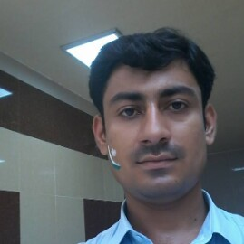
Cv
Personal information
Name : Tahir
Email: tahir.384946@2freemail.com
Date of Birth : 02/04 /1992
Nationality : Pakistani
Status : visitor
Religion : Islam
Gender : Male
Address : sharjah
Objective
I want to be part of a dynamic and progressive organization, which offers challenging working environment where one can utilize energies and competences in a positive direction and contributes towards overall objectives of an organization.
Academic Record
Name of Degree | Year | Institute Name | Marks Obtained | Total Marks | Percentage
Metric(ssc) | 2009 | G.H.S No 1 Bannu city | 809 | 1050 | 77%
F.sc | 2011 | G.P.G.C Bannu | 780 | 1100 | 71%
B.E Electrical Engineering(Telecom) | 2015 | Ust bannu | 3.09GPA | 4GPA | 77%
Diploma of information technology(DITcomputer) | 2017 | Tracks | 1134 | 1400 | 81%

COMPUTER SKILLS
- Proficiency inMS-Word, MS-Excel, MS-PowerPoint
- Excellent in preparing presentations
- Circuit Designing & Implementation using NI instruments (Multisim)
- Matlab.
Communication skill
English |  |  |  |  |  |  | Urdu
writing | Reading |  | speaking |  |  | listning | writing | Reading |  | speaking |  |  | listning
Excellent |  | Excellent |  | Fluent | Excellent |  | Excellent |  | Excellent |  | Fluent | Excellent

Experience in electrical field
I have 1.5 year experience in power substation (elect Grid).I know about ct (current transformer ) pt (potential transformer) relay, circuit breaker operation and testing of relay . I know about power transformer (function) and its different parts and associated relay . I worked in 500kv 220kv and 132kv transmition line . I worked in protection and instrumentation department and maintenance also .in short I have a sufficient knowledge about a substation (power Grid).
Experience in telecom field
I have 6 month experience in zong in maintenance . I worked as Bss engineer .I know about BBU RRH optical fiber 3G , 4G wave guide , microwave link RF antenna and different types of trouble shooting etc

