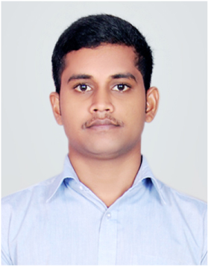
RISHAM
B.TECH in CIVIL

Email : risham.384949@2freemail.com

PROFILE SUMMERY

- B.Tech Civil Engineering Graduate from Al-Ameen Engineering College Shoranur– Kerala.
- 1-2 years experience in construction industry from one of the leading property developers in Kerala.
- Worked as a Junior Engineer in ValluvanadCH site in Perinthalmanna.
- Experience in leadership roles inTech Fest Coordinator and Job fair organizer at Al-Ameen. Engineering College, Shoranur.
- Proficient in AutoCAD, Staad pro , Primavera P6, Microsoft Office Tools.
WORK EXPERIENCE

Junior Engineer – Valluvanad Builders Perinthalmanna May 2017 – Sep 2018
ValluvanadBuilders is one of the leading property developers in Kerala which now stands at over with 160 completed projects.
JOB RESPONSIBILITIES

- Execution of work at site as per the drawings.
- Maintaining proper documents and drawings.
- Inspection of form works before concreting, and rebar spacing.
- Identifying and implementing best practice procedures.
- Ensuring good housekeeping and safety of works Men / Materials.
- Progress meetings with consultants and contractors.
- Verifying the variations, extra works and claims submitted by the contractors.
- Review and monitor monthly labor performance and utilization against the planned targets.
- Reporting observation and issues to the higher management with the resolution of any engineering issues and queries.
- Preparation of daily labour report.
- Critical Path Analysis and subsequent prioritization of work.
- Preparing time schedules ofworks .
- Managing team to ensure delivery of design in compliance to quality, time and budget.

PROJECT
Valluvanad Builders
- Foundation and Structural work of valluvand City Heights (VCH)
Position :- Junior Engineer
Location :-Perinthalmanna,Kerala
Duration :-May 2017 – Sep 2018
- Valluvanad city heights is a residential building of 1.2 lack square feet.
- B+G+9 storey building with 80 car parking spaces.
- Spread in 100 cents of land located at the heart of the City.
ACADEMIC PROFILE

COURSE | INSTITUTION/SCHOOL,CITY | DURATION | CLASS
B.Tech (Civil engineering) | Al-Ameen Engineering College,Shornur | 2013-2017 | FIRST CLASS
X11 (Kerala Higher Secondary) | GMHSS,Perinthalmanna | 2011-2013 | FIRST CLASS
X (Kerala Higher Secondary) | THSS,Angadippuaram | 2001-2011 | FIRST CLASS
ACHIEVEMENT AND ACTIVITIES

- Tech Fest Coordinator and Job Fair Organizer at Al-Ameen Engineering College, Shornur.
- Member of college football team 2014 – 2015.
- Completed skill development program under ICT ACADEMY OF KERALA.
PERSONAL DETAILS

- Date of birth :- 22/02/1996
- Marital status :- Single
- Sex and age :- Male , 22
- Languages known :- English, Malayalam

