CURRICULUM VITAE
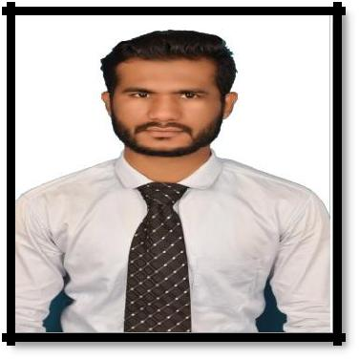

CONTACT INFORMATION

Aquib

ADDRESS | : | Bur Dubai, Near Burjuman Metro station
Email ID | : | Aquib.384976@2freemail.com

POST APPLIED : Architecture Draughtsman

Career Object :

To be a part of organization where the management structure recognizes & reward loyalty, honestly hardwork & ambition of an employee by providing growth opportunities.

PROFESSIONAL EXPERIENCE :

Company | : | Unique Arc Associates, Dapoli, Ratnagiri
Designation : |  | Auto Cad Designer.
Duration | : | For the Period of April 2016 to Till date.

Education Qualification :

Examination | Board / University | Year of Passing | Percentage /
 |  |  | Grade
REVIT | CADD CENTRE | February 2016 | Outstanding
 | Mumbai
Architecture | Mumbai University | April 2015 | First Class
Draughtsman
AUTO CAD | CADD Point Dapoli | August 2014 | A+
 | Higher Secondary
H.S.C. | Education Board | February 2013 | 39.33
 | Mumbai
S.S.C. | Secondary Education | March 2011 | 58.73
 | Board, Kolhapur

IT SKILLS |  | : | Auto Cad 2D & Isometric,
 |  |  | Revit Architecture.
 |  |  | Basic Knowledge of computer
Personal Details :
Date of Birth |  | : | 24 January 1996
Marital Status |  | : | Single
Nationality |  | : | Indian
Religion |  | : | Islam
Languages Known |  | : | English, Urdu, Hindi, Marathi
Hobbies |  | : | Driving cars and bikes travelling, Playing Cricket
Passport Details |  | :
Date of Issue |  | : | 31/12/2015
Date of Expiry |  | : | 30/12/2025
Place of Issue |  | : | Mumbai
Strength |  | : | Pro-Active, Assertive, Hardworking, Punctual, Honest
 |  |  | and a Quick Learner.

