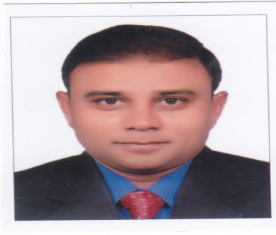
CV RAJEEV

PERSONAL INFORMATION
DATE OF BIRTH: 19-09-1969
E-MAIL: rajeev.384987@2freemail.com
PROFILE
Managing independently the overall functions of sales and marketing. Knowledge and capability of handling routine functions including, Appointment of C&F, Tapping new markets, Sales Promotions, Awareness Campaign to promote the brands, Credit Management and Activations, Inventory Management and Sales Invoicing, Support to Customer Service, exclusively responsible for Sales Generation.
I have been able to build rapport and sound working relationships with customers and colleagues, both face-to-face and over the telephone. I have always been committed to providing the highest quality of work delegated to me, using persuasiveness and presentation skills to win others over in work situations. I have also assisted in setting standards for following internal procedures.
A person with commercial acumen and customer focus
A person always greedy for sales and expects great out of him
Sales being my passion looking for climbing up the corporate ladder in a new challenging work place, culture, environment to prove my metal and create my presence with a bang
A honest sincere personality who has self belief and always tries to take a risk when others dont Not afraid of making mistakes
tries

EDUCATION:
1988-1991: Bachelor of science
Pune University, India(uae attested)

PROFESSIONAL EXPERIENCE
2007-2018 :REGIONAL SALES MANAGER
: A profit centre for the organisation
: Entrepreneurial thinker
: A person addicted to success
: A revenue generator for the company
: A leader leading from the front
: Successful handling of 45 stockists
: Successful in team management
: Responsible for sales and product handling process
: Solving issues related to stockists and field work
: Successful launch of division and products
: Reporting to vice president, marketing&sales

2001-2006 AREA SALES MANAGER
Successful in managing a team of 14 medical representatives
Being successful, I was given charge of 22 medical reps and new areas
For operation which were successfully done
Successful in handling and retaining a sales tem for 7 years with
Consistent sales performance
Reporting to Regional sales manager
1994-2001 MEDICAL SERVICE REPRESENTATIVES
Successful in selling concepts to doctors for sales generation
Successful in launching new molecules
Successful in working independently
Successful recovery rate of 100%
Reporting to Area Sales Manager

SPECIALIZED SKILLS : : Guts to accepts mistakesand failures
: A learner
: A good listener
: Credit to part to his subordinates
: Excellent interpersonal and communication skills
: Multitasking abilities with proficiency in organizing and managing
: Ability to recruit, train and supervise team mates
: Expert marketing skills to promote business
: Commercial Acumen
: Customer focus
: Negotiation skills
: Entrepreneurial mind set
: Sales passion and hunger to succeed
: Outgoing personality
: Self starter and highly motivated
: Command in written and spoken English, Hindi
INTERESTS : Extensive travelling &playing cricket

