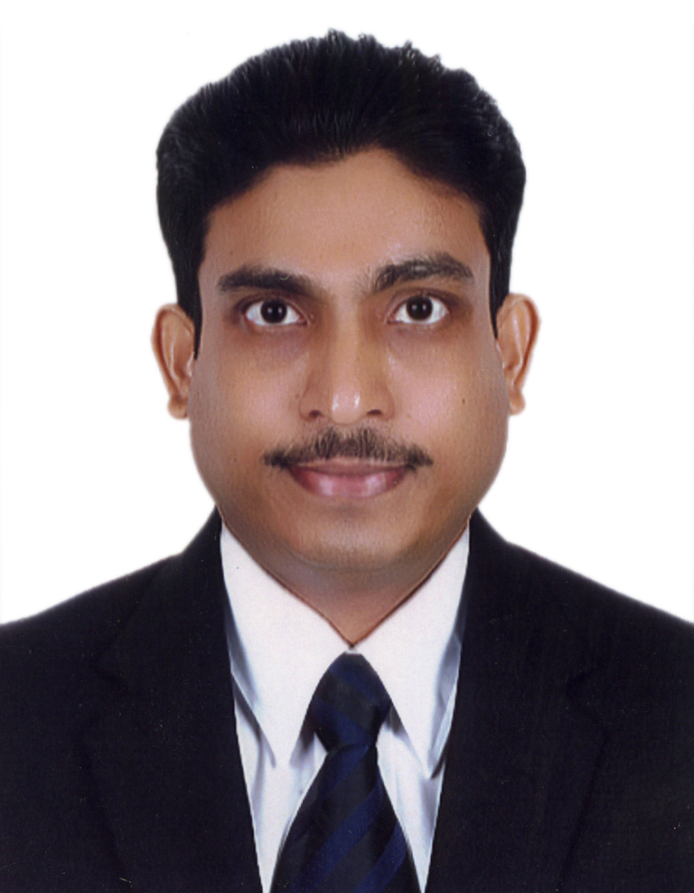GREGORY

E-mail : ​Gregory.385157@2freemail.com

CAREER OBJECTIVE

To be a dynamic professional and work in a challenging environment where my experience and strong work ethics can contribute to the growth of the organization and help me to further my career..

EXPERIENCE SUMMARY
- 3 years experience in Banking.
- 5 years experience in Administration.
- 10 years of experience in Networking & PC support.

EDUCATIONAL QUALIFICATION

- ​HSSC ​(Science Stream), through Goa Board of Secondary & Higher Secondary Education, Goa, India in March 1990.

- Diploma In Computer Science & Engineering (Polytechnic)​, through Board of Technical Examination Bangalore, Government of Karnataka, India appeared for Final year in May 1994.

TECHINICAL QUALIFICATION

- ❖ DIPLOMA IN ELECTRONIC AND COMPUTER HARDWARE​ ​(DECH)​ through Institute of Electronic Technology, Goa, India in Sep. 1995.
- ❖ DIPLOMA IN COMPUTER HARDWARE AND​ ​MAINTENANCE (DCHM)​ through Indian Technical Education Society ​(ITES)​, Bombay, India in May 1996.
- ❖ MCSE​ through ​GLOBAL NETWORK TECHNOLOGY ​(Authorized Training Center), Mumbai, India in Dec 1999.

WORK EXPERIENCE

First Gulf Bank/ After Merger First Abu Dhabi Bank U.A.E
Operations Processor from​ ​14th Oct 2014 to 28th Feb 2018.

Duties/Responsibilities (Branch Cash Service Unit)
- Preparing and dispatching Online Central Bank Vouchers for Cash Withdrawals/ Deposits to Transguard.
- Coordinating with service providers and Branch Tellers/ATM/CDM regarding Cash withdrawals, deposit receipts, cash functioning and delivery from/by Branches/Central Bank.
- Generate System entries.
- Arranging mail logistics with approved service providers both for cash and document transfers.
- Passing accounting entries for Banking Customers.
- Maintaining MIS for daily activities pertaining to customer transactions.
- Maintaining records of source documents.
- Handling of discrepancies and queries pertaining to customer calls.
- Daily verification/ reconciliation of accounting reports.

Leasing with Service Providers for various ATM/CDM Machines & arranging maintenance calls with Service Providers.

Issuance/Cancellation and Redemption of First Saving Certificates

- Preparing Monthly proofs and verification reports for management review.
- Issuance of Debit Cards.
- Scanning/Indexing of Bank documents .
- Processing of Account opening documents, maintenance and closing.
- Statement mailing to Bank staff.

Globaleye Insurance Brokerage L.L.C. Dubai, U.A.E
(Administrative Assistant from Nov 2008 to Sep 2014)

Duties/Responsibilities
- Vetting, processing, recording and dispatching new business applications to Provider offices.
- Generating periodic valuations, premium histories, premium arrears and policy surrender and maturity values for clients.
- Update client records and create/delete details on an ongoing basis.
- Maintaining the register of policy documents received , new credit card mandates, premium renewals, premium arrears, cheque receipts etc. and follow up for pending requirements.
- Recording/Tracking change of agency in/out and compiling a report for management on monthly basis.
- Providing full support to Administrative and Sales personnel.

NORTHERN EMIRATES INTERNET CENTER FZE’’​ SAIF ZONE, Sharjah, U.A.E. (Techo - Commercial Executive: ​From 2​nd​ Jan 2008 to Oct 2009)

Duties/ Responsibilities
- Handling customer calls from companies in the Free Zone Companies with regard to sales enquires.
- Providing technical support.
- Attending to service calls from Clients and cross selling Company products.
- Responsible for maintaining documentation and audit of daily activities for management.

MISHAAL AL SUDAIRY TRADING​,​ ​Bur Dubai, U.A.E.
(Sales Representative:​ ​From 8​th​ September 2006 to December 2007)

Duties/Responsibilities
- Stock-Management (Store In-charge for stores based in Sharjah, MF Jebel- Ali as well as showrooms.
- RMA Department​: Accepting & Testing Computer Accessories, Graphics Cards, MGE UPS System, Zalman-Products & Forwarding (email) RMA-Approval for replacement.
- Checking/preparing the invoice and generating receipt vouchers for clients.

WALNUT TECHNOLOGY​, Goa, India
(Network Engineer - September 2002 to February 2006)

Job Description​
- Windows 2000 Networking - Installing Windows 2000 Server.
- Implementing domains and the Active Directory.
- Managing & Maintaining Servers, users & groups.
- Maintaining volumes & disks. Configuring & setting NTFS permissions.
- Connecting with windows terminal services.
- Networking Windows 2000 Server & Windows 2000 Professional.
- Monitoring performance & security.
- Installing & configuring OS:-​ NT-Server 4.0, NT-Workstation 4.0, Windows 2000
- Server, Windows 2000 Professional, Windows (95, 98), Ms Office (2000,2003), Windows XP,​ ​Troubleshooting Networking & Printer related problems.
- Installation of Anti-Virus:​ ​(Dr. Solomon, Red Alert, Smart Dog, McAfee, F-Prot, Nash Shot, Norton, Trend Micro Office Scan Online Server-based Antivirus)

WYSETEK SYSTEMS TECHNOLOGISTS PVT. LTD​, Mumbai, India
(Network Engineer - June 1999 to August 2002)

Job Description​
- Configuring trouble-Shooting & Managing Novell Netware (2.X, 3.X 4.X)
- Windows 98 Network &Windows NT Systems.
- Accessing Novell resources from windows (98) or NT.
- Installing & Configuring a Two-node as well as Multi-node network.
- Sharing drives, folders, files & Printers. Troubleshooting Windows network.
- Windows NT Servers:​ ​System security, configuring viewing Windows NT file system with particular emphasis on NT & Backup’s.
- Networking & Integrating with different operating system & Upgrades
- Trouble shooting of Windows NT. Configuring & Supporting for print system.

PROWIDER COMPUTER SERVICE​, ​ ​Goa, India
(Application Support Engineer -July 1997 to June 1999)

Job Description
- Installing Various Software.
- Oracle forms 4.5, Reports 2.5, Power Builder, MS Visual Basic, MS Visual
- C++, MS-Office, Adobe Photoshop, PageMaker Animator Pro, 3D Studio. Corel Draw, Windows (3.11wg, 95,98)

UNICOM COMPUTER SERVICES​, ​Goa, India
(Hardware Engineer -Dec.1994 to July 1997)

Job Description
- Worked as a service Engineer from & responsible for assembling & testing system, installations of System, Printers, Fax Modem (internal, External),
- Multimedia, Tap Drives, Scanners, TV-Tuner-card LAN-Cards. Also repairs of (Mono VGA), SMPS, Uninterrupted power-Supplies etc

Personal Information
Nationality: Indian
Driving License: Valid for light vehicle

Personal Skills
Languages Known: English, Hindi and Konkani
Hardworking and able to perform under pressure
Meticulous and attention to detail

