CURRICULUM VITAE
IHSAN, B.Tech (Civil)  Email: ihsan.385241@2freemail.com  Sharjah, U.A.E | 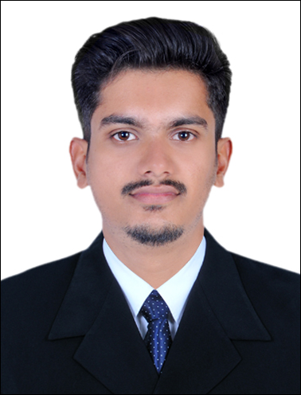

Career objective:
To work in a competitive organization that provides me opportunities for the growth of my knowledge & career by always keeping the organization goal as first priority.
Experience Profile:

A dynamic professional with 1 Year 4 months of experience in civil engineering construction field at Various companies in India.

Educational Qualification:

- B.Tech (Bachelor of Technology) in Civil Engineering,(2013-2017) Passed out from
Calicut University, MES College of Engineering Kuttippuram, kerala, India

Work Experience:

- 1 Years and 3 month of Professional Experience as Civil/Site Engineer in Build world constructions in India.(July 2017-Oct 2018)
Projects : Various Civil Construction Projects

Roles & Responsibilities:

- Daily monitoring & supervising the activities on civil work.
- Experience in detailed drawings of superstructures and substructures.
- Setting out the work in accordance with the drawings and specification.
- Managing the performance of Quality Assurance and Control activities in accordance with Project Schedule.
- Taking Quantity of materials and scheduling material&equipment purchase and delivery.
- Preparing Bar Bending Schedule and other working drawings.
- Preparation of Bill Of Quantity (BOQ) .
- Developing project specification &test plans for each section / discipline of the work.
- Attend meetings and conduct joint inspection with clients representatitve.
- Preparing project feasibility reports and estimates.

- 1 month of Professional Experience as Site Engineer in PCM Pvt. Ltd. in India.
Projects : Ladder Indian Mall Cum Apartment, Manjeri, India. (B2+G+14) –June17

Roles & Responsibilities:

- Setting out the work in accordance with the drawings and specifications.
- Measurement and valuation (in collaboration with Project Quantity Surveyor)
- Ensure progress of work as per schedule.
- Execution of site work.
- Checking levels and survey works as per needed.
- Preparing Daily Progress Report on basis of work done.

Technical Knowledge :
- Auto Cadd 2013
- STAADPro. (Beginner)
- MS office, MS project.
- Revit Architecture.
- Quantity Take Off (QTO).
- 3ds Max.(Beginner)
Area of Interests:
- Quantity Survey.
- QA/QC.
- Site Engineer.
- Auto Cadd Engineer.
Personal Strengths:
- Dedicated to job.
- Positive approach.
- Ready to learn new things and take new challenges.
- Ability to co-ordinate and work with a team.
- Punctuality.
Co-Curricular Activities:
- 10 day internship at Olive Builders , cochin, India.(Five B2+G+20 2&3 BHK flats)
- Done Project on feasibility study and design of proposed checkdam in palakkad,India.

Personal Details:

Date of Birth : 11.06.1993
Age : 25
Sex : Male
Religion : Islam
Marital Status : Single
Nationality : Indian
Driving License : India

Languages Known:
To speak English,Hindi & Malayalam
To read & write Arabic, Hindi, Malayalam and English

Declaration:
I hereby affirm that the information and particulars declared above are factual and accurate to the best of my knowledge and belief.

