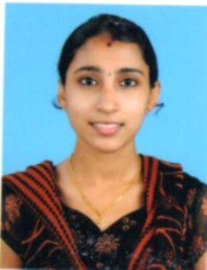

SWATHI

Email ID:swathi.385263@2freemail.com

CAREER PROFILE
Total 4 years of experience where 2years in Accounting and 2 years in Documentation and Visa processing. Looking for a challenging opportunity in an esteemed organization which will help me to exhibit my talents and my skills and to contribute for the development of self and organization

CORE COMPENTENCY
- TALLY ERP 9.0 (Including VAT), MS OFFICE CERTIFICATION
- PGDCA –Post graduation diploma in computer application – CORALDRAW, PAGEMAKER, C+, C++

CAREERHISTORY

RIYA TRAVELS
DOCUMENTATION AND VISA PROCESSING
August 20, 2016 – July 30, 2018

Riya - the Travel expert, established in 1990 is one of the India's leading travel organizations. With over 50 locations in India & 4 worldwide.

- Responsible for all Visa Service to countries like North and South American countries, Europe, Asia pacific and Gulf countries.
- Responsible for completion of all relevant visa documents and ensure that they are received within the time limit set by the government.
- Preparing and checking all legal documents.
- Handling client queries over the phone and in meetings & emails.
WEBTEL
ASSISTANT ACCOUNTANT
July 04, 2014 – March 30, 2016

Webtel India, established in 2001 delivers top level BPO’s with professional Data Entry and Claim Processing services in allover India.

- Processing daily invoices.
- Reconcile bank statements by comparing transactions to the general ledger.
- Responsible for maintaining records of invoices, payments and transactions.
- Preparing purchase orders,
- Maintaining petty cash.
- Process cheques and keep filing and invoice monitoring systems up to date.
- Provide administrative support to accountants with day-to-day operations of the Finance department.
- Maintain accounting documents and records, ensuring all files are up to date.

EDUCATION

Pre- University Course | Shri Ramakrishna Pre-University College, Mangalore | Completed 2011 | 83%
Bachelor of Commerce | Mangalore University College, Mangalore | Graduated 2014 | 80.68%

PERSONALDETAILS

Date of Birth :April03,1994
Status :Married
Citizenship :India
Visa Status : Visit Visa
Availability : Can join immediately
Languages : English, Hindi and Kannada (Native)

REFERENCESUPONREQUEST

