CAREER OBJECTIVE:

TO BE ASSOCIATED WITH AN ORGANIZATION THAT GIVES SCOPE TO USE MY KNOWLEDGE AND SKILL TO BE A PART IN TEAM ENVIRONMENT AND WORK FOR THE SUCCESS OF THE ORGANIZATION.

Summary

JEEVITHA
Possesses overall 6 years of Accounting experience.
Has worked in VAT & GST system.
Experience on TALLY ERP.9.
Counter cash Handling.
Ledger maintaining.

E-MAILS

Jeevitha.385325@2freemail.com
Certification and Achievements

PGDCA Certified
Tally ERP.9 Certified
Participated Karnataka state level National Service Scheme. I have also received appreciation certificate.
Received numerous rewards & recognitions for best quality of work. I have also received many customer and client appreciations during my tenure in
RELIANT HUME PIPE CO. MANGALORE, KARNATAKA INDIA.

Work Experience at India:

WORKED AS AN ACCOUNTANT FOR 4 YEARS AT RELIANT HUME PIPE CO.
MANGALORE, KARNATAKA INDIA
WORKED AS AN ACCOUNTANT & CASHIER 2 YEARS SOUZA ELECTRONIC S UDUPI KARNATAKA INDIA.

PERSONAL DETAILS
DOB: 29-04-1989

Duties & Responsibilities:

Worked on all types of severity issues and shown a lot of maturity dealing with customers in panic situation.
Job involved extensive on call customer interaction
Interacting with various teams and accounting groups as well as sound knowledge and experience.
Worked as lead in case of lead’s absence and ensured smooth work flow.
Handle high man power nearly 10-15 members.
Upgrade technical skills for self by attending trainings, seminars etc.

Sex: Female

Nationality: Indian

Languages Known: English, Hindi, Kannada & Tulu

ACADEMIC PROFILES

Qualification

Board Institution Year of
Passing

Percentage
Obtained

Marital Status: Married

Passport Details:
DIPLOMA in
E & C
Karnataka Govt.
Bangalore
G.W.P.T BONDEL 2011 63% MANGALORE
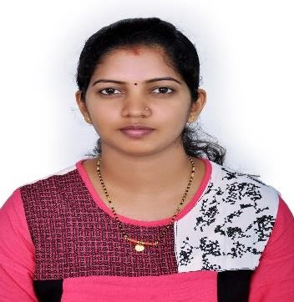
rr
Type: P

Country Code: IND

Nationality: Indian

P.U.C
Department of Pre- University Education

Govt PU College, Sajipa
mooda2007 69%

Date of Issue:
01/08/2018

Date of Expiry:
031/07/2028

S.S.L.C

Karnataka Secondary Education Board

GOVT HIGH SCHOOL, SAJIPA MOODA

2005 68%

Place of issue:
Bangalore

HOBBIES

Listening music, Reading Books, Tailoring, Shuttle Badminton, Watching T.V, Traveling, Long Raiding.

DECLARATION

I hereby declare that the above-mentioned details are true and correct to the best of knowledge. If given an opportunity to serve your organization, I promise to do my duties to at most satisfaction of my supervisors.

Date:
Place: (Jeevitha)

