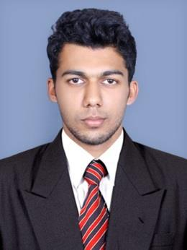
Don

Don.385469@2freemail.com

Professional summary

Looking forward for an opportunity wherein I can improve my academic and professional qualification and utilize my wisdom in a highly esteemed organization. Highlights will to carry out the assignment in the specified time limit. Prove efficiency in niche of employment.

Work history (September 2016- August 2018, AQUA GROUP)

Mechanical Engineer (Follow Up)

I graduated with Bachelors in Mechanical engineering in the year 2016, and have worked for Aqua Group of industries since then. Initially I was an employee of Aqua Sub Engineering, which specializes in manufacturing motor pumps. I worked along the production line, gaining a well versed knowledge in Horizontal and Vertical CNC machines.

Skills

- Stress management skills, Leadership & Excellent organizational skills.
- Understanding plant operations.
- Good Knowledge of plant maintenance strategies.
- Ability to meet deadlines, Supervisory experience and Quality control experience.

- Showing proficiency in MS office and planning software.
- Preparation of daily reports & variations in planned & achieved targets.
- Maintain tracking record for Items for refurbishments.
- Update histories on regular basis.

- MS Word, MS Excel.
- CAD Software, Solid Works.

- CNC Programming and Operating in both Vertical & Horizontal turning machine.

Certification Training

- QA/QC in Mechanical Engineering
- QA/QC in Welding Inspection
- Piping and Pipeline Engineering
- NDT level 2 Engineer

Education

2016 - B.E Mechanical Engineering (Loyola Institute of Technology & Science, Anna University Chennai)

Academic Project: MODIFIED FABRICATION & DESIGN ANALYSIS OF TRANSFORMER TANK

I had done my project in Kerala and Allied engineering Co. Ltd (KEL).The transformer tank is usually fabricated by using six MS-Plate. We redesign the tank plate into two welded joints, by joining the HV and LV plates. As a result the cost and number of labour participation can be reduced. The main advantage of this process is that the mass production can be achieved and the reduced labour cost. Successfully attended a three-day ROBOTIC workshop conducted by TECHNOPHILIA, Mumbai. Participated in national seminar on Nano science conducted by Loyola Institute of Technology and Science.

Personal Information

- Date of Birth: 23-09-1994
- Nationality : Indian

- Marital Status : Single
- Languages: English, Malayalam,Tamil,Hindi
- Visa Status – Visit

