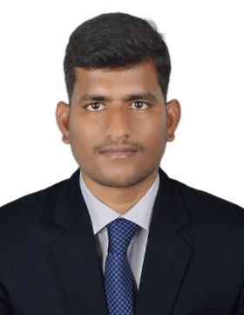
SRINIVAS
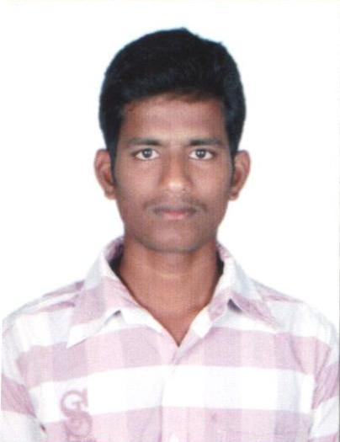
Civil Site Engineer
Email: srinivas.385687@2freemail.com
Current Address: Bur Dubai, Dubai, UAE

CAREER OBJECTIVE
Seeking a position as a Civil Site Engineer that challenges me and provides me the opportunity to reach my full potential professionally and personally utilizing my 5 years of experience in growth-oriented organization

PROFILE AT A GLANCE
- Astute Professional with over 4 Gulf years of versatile dexterity in Planning, Construction, Quality assurance & Erection of Precast Structural Elements.
- Being able to negotiate to reduce and cost & duration of the project
- Attention to detail and perform well in competitive environment.
- oversee quality control and health and safety on site
- Proficient in managing task and organizing work, challenges visioning and continual achiever.
- Exceptional Technical & Management Skills.
- Preparing Shop drawings & Installation of Precast Structures is an Additional advantage.
- Well versed in MS Office, AutoCAD, STAAD PRO and JWD Structures.

PROFESSIONAL OUTLINE
ANAMAQAWL for Contracting-
Dammam, Saudi Arabia, C.R. 1010332234
Designation : Site Engineer
Duration : Feb 2015 to Aug 2018
Projects Handled:
- Construction of Commercial Project K-64 (B+G+3+R) (6200 Sq.mts) in Dammam, KSA.
- Construction of Al GoniamVilla in Area of (2750 Sq.mts) in Dammam, KSA.
- Construction of Commercial Complex K-82 Al-Fares (B+G+2+R) (9400 Sq.mts) in KSA.
- Construction of Precast Residential Villas (G+2) in Al jubail, KSA

TUMMALA INFRASTRUCTURES PVT.LTD
Vijayawada, Andhra Pradesh, India.
Designation: Site Engineer
Duration : August 2014 to January 2015
Projects Handled:
- Construction of foundations, supply, fabrication and erection of steel structures for platform shelters for Vijayawada Railway Station
MAHAVEER CONSTRUCTIONS
APHB Colony, Guntur, Andhra Pradesh
Designation: Site Engineer
Duration : Jun 2013 to July 2014
Projects Handled:
- Construction of Civil works with Monnet Power Corporation in Orissa, India.
- Construction of Residential Buildings with National Thermal Power Corporation (NTPC) in Pune, India.
Role & Responsibility:
- Assisted the site-in-charge for Construction activities in Sub & Super Structure of the Project including Interior, Exterior Works, Finishing Works and Precast Structures.
- Check plans, drawings and Prepare preliminary and detailed estimate of Project.
- Recorded the measurement of BOQ, BBS, RA BILL, Quantity Abstract, work Slip, Deviation Statement.
- Ensure that all materials used and work performed are in accordance with the specifications
- Oversee the selection and requisition of materials
- Agree to a price for materials and make cost-effective solutions and proposals for the intended project
- manage, monitor and interpret the contract design documents supplied by the client or architect
- liaise with any consultants, subcontractors, supervisors, planners, quantity surveyors and the general workforce involved in the project
- liaise with the local authority (where appropriate to the project) to ensure compliance with local construction regulations and by-laws
- communicate with clients and their representatives (architects, engineers and surveyors), including attending regular meetings to keep them informed of progress
- Prepares the weekly/monthly progress reports for submission to client and HO Project Control Department.
- Resolve any unexpected technical difficulties and other problems that may arise.
EDUCATION CREDENTIALS
- Bachelor of Engineering in Civil Engineering from JNTU University, Kakinada, AP (2009-2013) with First class with distinction (80.10%)

ACHIEVEMENTS

- Covered Slab area 1060 Sq.mts by Erection of Hollow core Slabs (120 Panels)
- Achieved Complimentary Bonus for Completed the assigned schedule within period
PERSONAL DETAILS
Date of Birth : 13 Aug 1992
Nationality : Indian
Languages Known : Arabic, English, Hindi and Telugu
Marital Status : Married
Visa Status : Visit Visa
Diving License : Valid Indian Driving License
Joining Status : Immediate
I declare that all the information given above is true to the best of my knowledge.

