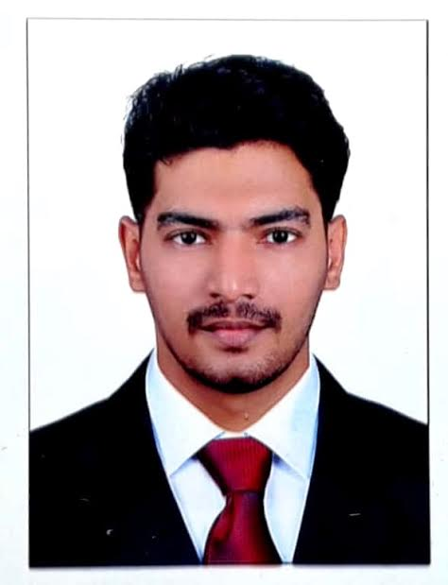
MUNEER
Email: muneer.385709@2freemail.com

OBJECTIVE
ANAESTHESIA TECHNICIAN

CAREER OVERVIEW

Qualified and experienced in Anesthesia and Operation Theatre Technician. During this tenure obtained good exposure and experience in assisting the Anesthesiologist during anesthesia (General & Regional) procedures and maintenance of operation theatre equipments and machines. Has acquired ability in assisting the anesthesia procedures in various departments like General Surgery, Gynecology, Maxillo-Facial, Orthopedics, Neuro-Surgery, and ENT including Cochlear Implantation, Laparoscopic surgeries and also experienced in stock inventory management, record keeping and man power management.
Course | Year | College / Institute | University / Board
Diploma in Operation Theatre & Anaesthesia Technology (DOTAT)  (Course Conducted Under Department of Anaesthesia) | December  2014 | Al-Shifa Collage of Paramedical Sciences, Perinthalmanna | Directorate of Medical Education (Govt. of Kerala)
Plus Two SCIENCE | March 2011 | GGBHSS malappuram | Board of higher secondary examination
SSLC | March 2009 | DUHSS PANAKKAD, MALAPPURAM | Board of public examination

PROFESSIONAL QUALIFICATION
Dubai Health Authority (DHA) Approved
Date of examination: 30/04/2018
Date of approval: 01/05/2018
Data flow case

American Heart Association (ASA) Approved
Basic Life Support provider

EDUCATIONAL QUALIFICATION

PROFESSIONAL EXPERIENCE

As anaesthesia technician

1. I have 2 years experience fromKIMS AL SHIFAHospitalNABH Accredited and ISO 9001: 2000 Certified, 550 Bedded Tertiary Level Referral Hospital, Perinthalmanna, Kerala, Indiafrom November 2014 to November 2016.
(From 17.12.2014 to 13.11.2016 )
2. 1.8 years experience from AHALIAhospital palakkad,Kerala,India.
(From 16.2.2017 to 25.10.2108 )
EXPERIENCE AND RESPONSIBILITIES HELD
ANAESTHESIA FIELD
- Assisting Anaesthesiologist for anaesthesia procedures (fibro optic intubation, CVP catheter insertion, arterial cannulation and supra clavicular,interscalene, femoral,sciatic blocks with USG
- Preparation of Anaesthesia trolley and medicine tray
- Positioning and Monitoring of patients
- Post Operative care of patients
- Emergency Airway management
- Endo-tracheal Intubation
- Anaesthesia Ventilator management
- Maintenance and trouble shooting of Anaesthesia Machine
- Maintenance of central gas supply
EMERGENCY MANAGEMENT
- Airway management and Endotracheal Intubation
- Trauma management
- Post-anesthetic Emergency management
- Basic Life support
- Peripheral and central venous cannulation
BIOMEDICAL FIELD
- Maintenance and trouble shooting of anesthesia machines ,monitors and ventilators
- OT lights and Tables
- Operativemicroscopes.leicaC6,ziess s8

PERSONAL PROFILE

Date Of Birth :21/04/1992
Gender :Male
Nationality :Indian
Marital Status :Single

DECLARATION

I do hereby declare that all the information provided in this curriculum vitae is true the best of knowledge and belief

