Name: KHALID NSUBUGA 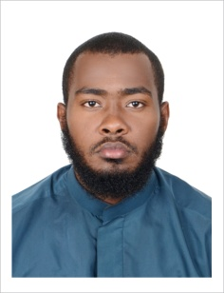
Address Email: km83334@gmail.com
Contact: +971561989297
POST: Gym and fitness Trainer
CAREER OBJECTIVE:
A dynamic smart young man with a sound professional background seeking for placement in collaborative and challenging environment with the objective to improve my career and support the organization to a achieve its goals.

OVERVIEW:
A result oriented self-starter still learner efficient communicator.promble solver with ability to focus on solution and proactive diet food to loss and gain weight.

WORKING EXPERIENCE:

POWER HOUSE GYM
Duration: Aug-2014 - Mar-2017
Position: GYM INSTRUCTOR

EDUCATION BACKGROUND:

HIGH SCHOOL

ACHIEVEMENTS & AWARDS:

- UACE, UCE, Certificate
- DIPLOMA

April 2018: HSE Certificate of Recognition
Warner Bros. World Abu Dhabi car park, Yas island ,Abu Dhabi
January 2018: HABC Level 2 International Award in Emergency First Aid at Work.
Dubai Corporation for Ambulance Service.

QUALIFICATOINS:

- C P R and First Aid
- Health and safety

SKILLS:

- Weight Training.
- Fitness Programs.
- Nutritional Planning.
- Present a professional and attitude at all times, and maintains an excellent standard of customer service.
- Ensure health and safety is to the highest standard.
