CURRICULUM VITAE
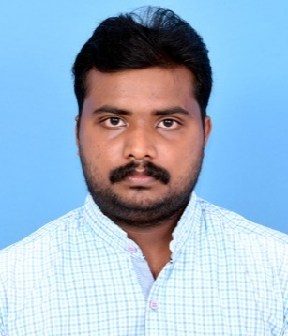

AJIN
B.TECH IN CIVIL ENGINEERING
E-Mail : ajin.385931@2freemail.com

Career Objective
To succeed in an environment of growth and excellence and earn a job which provides me job satisfaction, self-development and help me achieve personal as well as organization goals.

Education

btech civil| btc college of engineering & TECHNOLOGY
- MG UNIVERSITY- 2016 || 65%

XII |MATHA SENIOR SECONDARY SCHOOL
- COMPUTER SCIENCE-2012 ||CBSE 70%

X |MATHA SENIOR SECONDARY SCHOOL
- 2010||CBSE 90%

Experience

SITE ENGINEER | KALARICKAL CONTRACTORS | JULY 2016 - september 2018
- 2years experience in various railways, Kerala PWD, residential & high raised buildings.
- Inspected project sites to monitor progress and adherence to design specifications & safety protocols.
- Led other engineers and technicians.
- Served as onsite project representative to client and crew members.
- Operated large commercial project under budget with effective management of people and materials.
- Drove business growth with positive client relations and staff development.

Software Proficiency
- STAAD Pro , AutoCAD
- Proficient in MS Office, MS Projects and PDF tools .

Personal Information
- Gender : Male
- Date of Birth : 13/07/1994
- Languages known : English, Hindi, Malayalam

Skills
- Excellent communication skills . Structural analysis
- Commercial & residential planning . Technical reports
- Public relations . Construction site management
- Client relations . Design computations

Achivements
- University college councilor [2015-16]
- BTC students council member[2014/16]

Declaration
- I do hereby declare that the above information is true to the best of my knowledge.

Ajin

