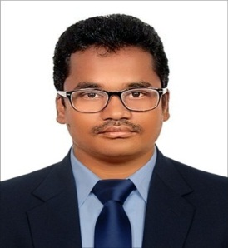
Vikas
Email: vikas.386426@2freemail.com

Career Objective:
I am looking forward to work for an organization that offers both personal and professional growth while being resourceful, innovative and flexible.

Academic Details:

Examination passed | University | College | Year of passing | Class | % of marks
B. Tech [EIE] | JNTU  Hyderabad | VNR Vignana Jyothi Institute of engineering and technology | 2016 | First | 63.4
Intermediate  [MPC] | Board of Intermediate Education | Vignan Vidyalaya Junior College | 2012 | Distinctive | 95.3
10th | Central Board of Secondary Education | Jawahar Navodaya Vidyalaya | 2010 | Distinctive | 86

Work Experience:
I have more than two years of experience in Instrumentation Cable Schedule, Digital and Analog Cable laying, installation of instruments,Trouble Shooting,loop checking and commissioning.
Position: Assistant Engineer
Tenure: 15th June, 2016 to 31st August, 2018

Project Experience:
- Reactor Process Automation
- Utility Dispensing Automation
- Temperature Control Automation

Academic Projects:
During my under graduation I worked on a projects
- “Image Based Password Authentication using Touch screens” to provide an easy accessibility for illiterates.
- “Solar Refrigeration System for Vaccines in Rural Areas”, which improves the transportation of vaccines to rural areas and preservation of vaccines in rural areas.

Certification Course:
I have completed Post Graduation Diploma in Industrial Automation(PGDIA) from Prolific Systems and Technologies affiliated to AREF Group, the course covered training in
- Programmable Logic Controllers
- Distributed Control Systems
- Variable Frequency Drives
- Industrial Process Management
- Panel Designing
- Human Machine Interface

Instruments Knowledge:
- Transmitter - Temperature, Flow, Level and Pressure.
- Switches – Flow and Level
- Control Valve
- Weighing System – Load Cell
- ON/OFF Valves

Skills Summary:
- Installation of Access control systems and Security systems.
- RTD sensors calibration.
- DTM Temperature indicators calibration.
- Configuring and faults diagnosis of Control Loops.
- Installation, calibration and loop checking of the field instruments (Polmon, Emerson, Rosemount, Honeywell).
- Technical Support for the instrumentation team.
- Spares balance investigation and inventory control for all instruments spare parts.

Personal Details:
Full Name: Vikas

