Contact Information

Shamnas (H),

PO.Thalakkulathur, Calicut -

673317, Kerala, India

niyas.386430@2freemail.com

Personal Profile

Name: Niyas

DOB: 12.07.1989.

Nationality : Indian.

Languages Known

- English

- Arabic: Read&Write.

- Hindi: Read&Write.

- Malayalam

- Tamil: Speak.

Interests

- Travelling

- Reading

- Photography

- Sports

Niyas
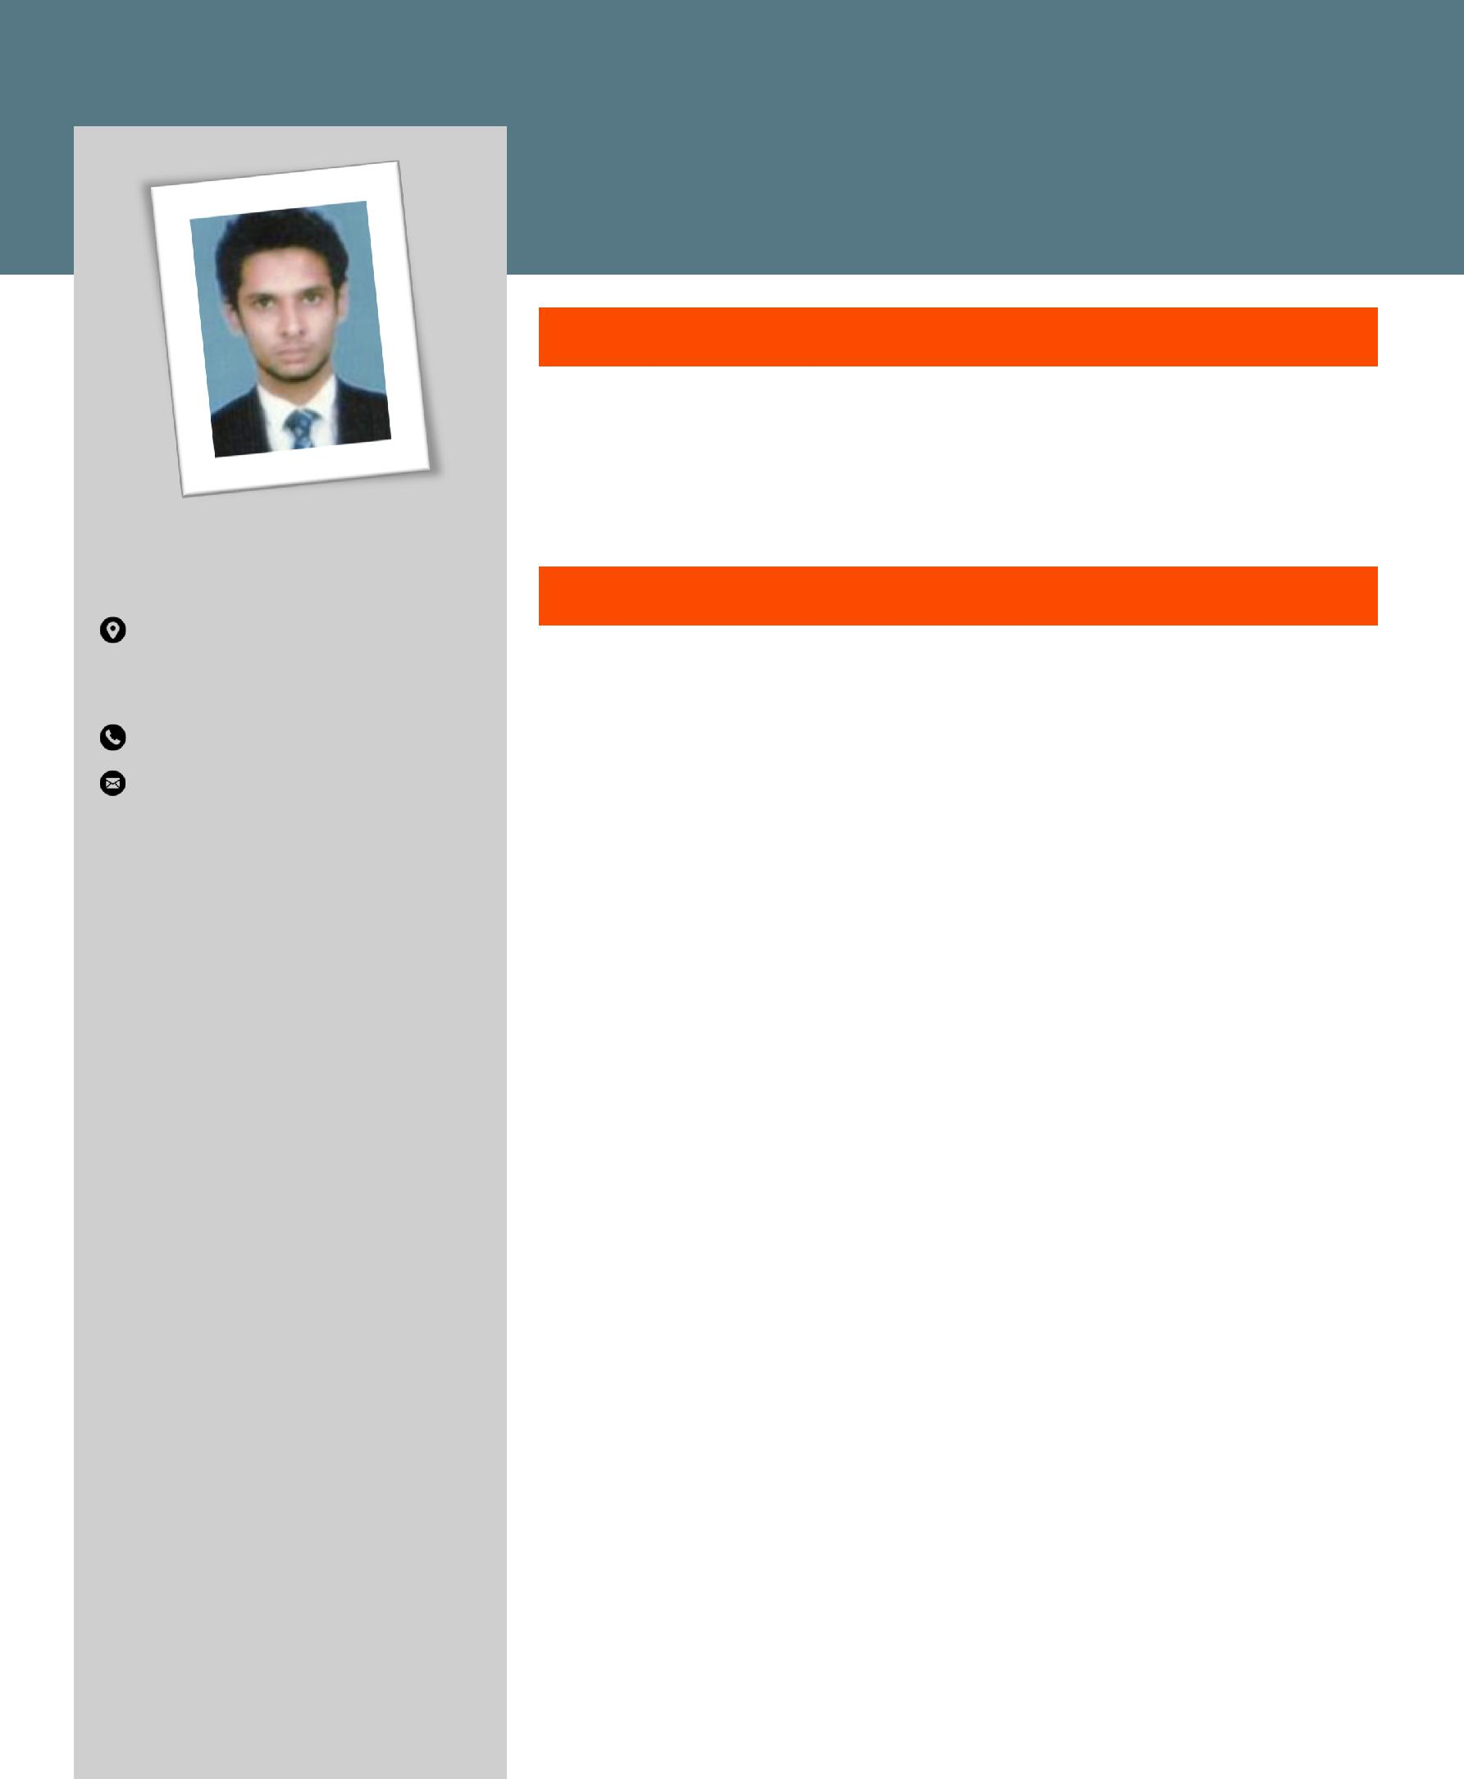

Assistant HR Executive

Summary

Qualified Human resources and Finance professional with a record of exceptional performance in the industry. Holds proven ability to design and deliver diversified, comprehensive, highly successful accounting initiatives. Also holds excellent customer service, payroll and relationship building skills.

Work Experience

Assistant HR Executive May 1st 2015 – Present

My duties and responsibilities include all the functions of HR. Maximized employee potential with innovative and dynamic initiative, effectively utilizes employee capital, combines long term strategic thinking with short term execution and helps the company meet its overall HR requirements.

≡ Update Staff List periodically as per the frequency and provide the information to the concerned departments.

≡ Assisting in payroll process on salary Time ≡ Preparing payroll reports and WPS Reports

≡ Record data for each employee such as address, weekly earnings, absences, supervisory reports on performance and dates of and reason for termination

≡ Process the Medical and Group Life insurance for the employees along with workmen compensation fund.

≡ All bank related paper work for the employees. ≡ OHC card process for the employees.
≡ Preparation of Employee EOS and leave settlement.

≡ Coordinating with the travel agency for employee tickets and visit visas. ≡ Initial Induction of Employees.

≡ Coordinating with all the department to assist their HR needs. ≡ Employee Personnel file management.

Sales Executive November 2013 – December 2014

HDFC Bank, Calicut, Kerala, India

My duties and responsibilities include acting as a contact between the company and its existing and potential market.

≡ Maintaining and developing relationships with existing customers in person and via telephone calls and emails

Key Competencies

- Determined

- Adaptable

- Hardworking

- Truthful and God fearing

- Honest

≡ Cold calling to arrange meetings with potential customers to prospect for new business.
≡ Responding to incoming email and phone enquiries.

≡ Listening to customer requirements and presenting appropriately to make a sale.

≡ Acting as a contact between a company and its existing and potential market.

Computer Skills

- Windows-XP, Windows-7: MS Office, Word, Excel & Familiar with Internet.

- Tally 7.2

- Good Typing Skills

Education

(1) Master of Business | (2)Bachelor of Commerce
Administration (HR and Finance) | University of Calicut
University of Calicut | 2011
2013

(3)HSE (4)SSLC

State Board of Higher Secondary State Board of Secondary Examination

Examination - Kerala – Kerala

Projects Undertaken

- Academic Main Project in Finance - “Performance of Financial Analysis” from Parrisons Roller Mills Kerala, 2013

- Academic Minor Project in Human Resources “Measuring Employee Morale’ from Califer Footcare PVT Ltd Kerala, 2012.

Declaration

I hereby declare that all the above furnished details are true to the best of my knowledge and belief.

Niyas

