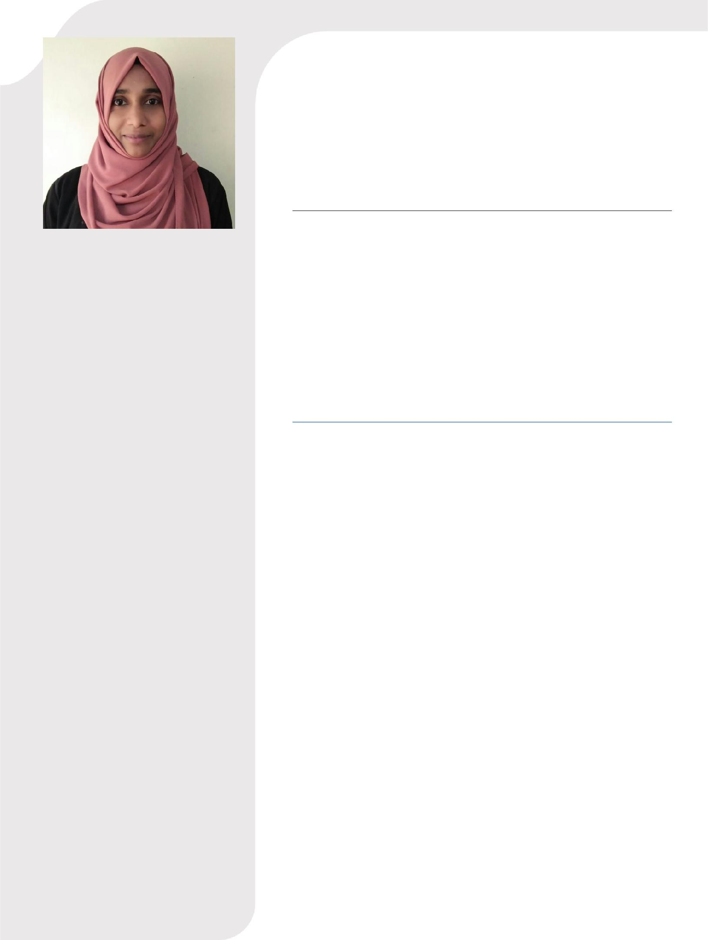

PROFILE

TO APPLY MY KNOWLEDGE AND SKILLS IN THE VIBRANT FIELD OF GLOBAL HEALTHCARE SYSTEM AND PLAY A KEY ROLE AS A PHARMACIST AS WELL AS TO ENRICH AND ENHANCE MY KNOWLEDGE, SKILLS AND MAKE CONTRIBUTION FOR THE ORGANIZATION GROWTH. MOREOVER, TO GET A CHANCE TO WORK WITH PROFESSIONAL STAFF TO LEARN AND UTILIZE MY PRE-EXISTING QUALIFICATIONS.

EMAIL:

Nadeera.386498@2freemail.com

NADEERA

PHARMACIST

EDUCATION

B PHARM AL SHIFA COLLEGE OF PHARMACY -2012 Calicut university

HIGHER SECONDARY EDUCATION

Government GVHSS KERALA-2007

SSLC

JMHSS TIRUR Kerala-2005

WORK EXPERIENCE

4 YEAR EXPERIENCE IN PHARMACIST

(12-01-2013 to 30-03-2015)

(01-05-2015 30-08-2017

- RECEIVING PRESCRIPTIONS AND FILLING ACCORDINGLY.

- MANAGE ALL TYPE OF HEALTH INSURANCE PRESCRIPTION

- MANAGE CONTROLLED AND SEMI CONTROLLED PRESCRIPTION.

- PATIENT COUNSELING AND PROVIDE PROPER GUIDANCE IN ADMINISTRATOR OF VARIOUS MEDICATIONS INCLUDE OTC, CONTROLLED ,SEMI CONTROLLED PRESCRIPTION,NUTRITIONAL PRODUCTS,SPORT NUTRITION AND MEDICAL EQUIPMENT.

- CHECK FOR HARMFUL DRUG INTERACTION AND ADVERSE EFFECTS.

- MAINTAINING OPTIMUM INVENTORY.

NATIONALITY | : INDIAN

P E R S O N A L D E T A I L S

NAME | = | NADEERA
DATE OF BIRTH | = | 11/02/1988
GENDER | = | FEMALE
RELIGION | = | ISLAM
NATIONALITY | = | INDIAN
NOTICE PERIOD | = | HUSBAND VISA
LANGUAGES | = | ENGLISH, HINDI, MALAYALAM

PERSONAL SKILL

- Statistics and Computer Applications.

- Excellent verbal and written communication skills.

- Ability to work in a team environment.

- Willingness to share successes and collaborate with others.

- Tremendous enthusiasm in learning new things.

DECLARATION

I hereby declare that all the details furnished above are true to the best of my knowledge and if found false I am wholly responsible.

Place:

Date : Nadeera.

