Reji 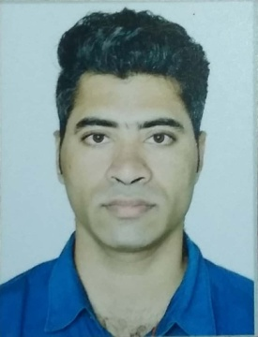
Email-: reji_386900@2freemail.com

*Objective* Seek a fulfilling position that will allow me to fully contribute my knowledge and skills in business development.

*Experience* April 1, 2014 to October 31, 2018

Post- Office Management

Job Role & Responsibilities
- Manage different government educational projects.

- Maintain and update personal record for staff.

- Manage schedules and deadlines.

- To do online registrations and online payments.

- Provides daily reports to employer.

- Attention to detail and problem solving skills.

- Depositing collected cash and cheques in bank.

- Protects organization's value by keeping information confidential.

- Collecting & Posting customers payments by cash, cheques.

- Preparing and Sending E-mail’s.

- Calling and Sending E-mails reminders for payments.

- Managing overall office activities and achieve the objectives & goals set by the management.

- Sending daily reports to the boss.

High lights & Core Competencies

- Energetic and enthusiastic to my Work.

- Self-motivated, hardworking, coachable and always eager to learn.

- Always ready for a flexible approach and work for an extra mile to achieve the goal.

- Maintain neat, clean appearance of self and work area to ensuring company safety.

- Policies and procedures are followed at all time.

- Ability to pick up new skills easily.

- Deal people with respectful and considerate manner.

- Always show great positive attitude and calm nature towards employee and with my work in any condition.

- Always ready to help and share my knowledge with my colleagues and employees.

*Education* March 2011
William Carey University
(Bachelor of Computer Application)
Meghalaya, India
- Computer Science

*Personal Information* Date of Birth : September 12, 1989
Gender : Male
Nationality : Indian
Visa Status : Visit Visa
Martial Status : Unmarried

I hereby certify that the above information is true and correct to the best of my knowledge and abilities.
REJI

