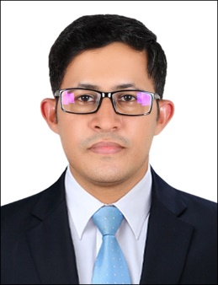
TAUSEEF
Email: tauseef.387073@2freemail.com

OBJECTIVE
Seeking a challenging position in a professional environment, which would enable me to develop professionally through enrichment of experience, effective use of my skills allowing the benefits of my qualification and experience to accrue to the achievement of goals of the organization.

ACADEMIC QUALIFICATION
B. Tech (Mechanical) 2014-2016 Indus University Karachi
Intermediate (Arts) 2014-2016 Board of Intermediate Education Karachi
DA (RAC) 2011-2013 GCT of Technology Karachi
Matric (Science) 2007-2008 Board of Secondary Education Karachi
PROFESSIONAL QUALIFICATION:

IOSH Managing Safety Trends International March, 2016 (City & Guilt UK Affected)

UNITED ARAB EMIRATES
Fire Fighter Training (2017)
NATIONAL CERTIFIED

First Aid CPR June (2016)
Fire Safety June (2016)
Safety Officer June (2016)

COMPUTER SKILLS:

Windows Professional 2010, XP, Vista
Microsoft Office (Word, Excel, Power Point)
Internet and Email

WORK EXPERIENCE
- Logistics Assistant
Mattex Yarns Production Company LLC in Abu Dhabi
- Wrapped pallets and attach batch number according to their quality,color and order number.
- Insure that variety of products cannot mix to each other.
- Insure that all production line have material according to their requirements.
- Manage shipments according to schedule time and destination safely.
- Proper reports of shipments, upcoming orders and complaints from customers. Aug 2017 to till date.
- 7 Month Working experience as a Machine Operator WithMattex Yarns Production Company.LLC in Abu Dhabi. Jan 2016 July 2017
- 03 Years Training Instructor & Team Supervisor, assembling body fitter experience in “Welding Depart Vehicle Body & Safety Depart Merge (PPE Awareness Class)” at Indus Toyota Motor Company.
- 03 Years “Apprenticeship Holder Weld”.
- 03 Years Job experience Welding Depart as a Team Supervisor, Vehicle Body Fitter Quality Controller at Indus Toyota Motor Company.

ADDITIONAL SKILLS
Good Communication Skills and Carry the prominent works
Strong sense of responsibility and self motivated
Good activity and hard working

PERSONAL:

D.O.B : 15-06-1989
Marital Status : Single
Nationality : Pakistani
Religion : Islam
Languages : Urdu, English, Hindi

