CURRICULAM VITAE
KARTHICK 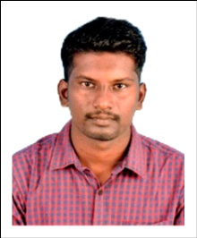
Email: karthick.387398@2freemail.com

OBJECTIVES:
To seeking permission in an organization that will recognize and utilize my skills fully and offer me a position requiring innovative and creative ideas continuous growth and learning are way of life.
EDUCATION:
- B.E Mechanical Engineering in Chendhuran College of Engineering and Technology,Pudukkottai affiliated to Anna University,Chennai,India in 2015.
- D.M.E from Annamalai Polytechnic College Chettinadu in 2009.
WORKING EXPERIENCE:
- Worked as a Junior Engineer in Sona Koya Steering System in Chennai (2009 to 2010).
- Worked as Maintenance Engineer in Mr. Arunachalam Industrial Training Institute, Pudukkottai (2015 to 2017)
SKILL PROFILE:
Operating system : MS-Word, MS-PowerPoint &MS-Excel.
Packages : AutoCAD
TECHNICAL SKILLS:
Knowledge of Two Wheelers Mechanism.
Knowledge of Automobiles.
PROJECT DETAILS: (BE)
- Design and Fabrication of Air Assisted Exhaust breaking system.
- Experimental Evolution of Mechanical properties of Coir, Jute,Glass,Fiber Materials (Composite Material)
PROJECT DETAIL: (D.M.E)
- Design and Fabrication of Vertical Mini Milling Machine.
EVENT ORGANIZED:
- RAMM 11 – A National Level Conference Organized by Mechanical Student’s Chapter.
- TORSION 11 – A National Level Technical Symposium Organized by Mechanical Student’s Chapter.
PERSONAL DETAILS:
Gender : Male
Nationality : Indian
Religion : Hindu
Languages : English & Tamil

