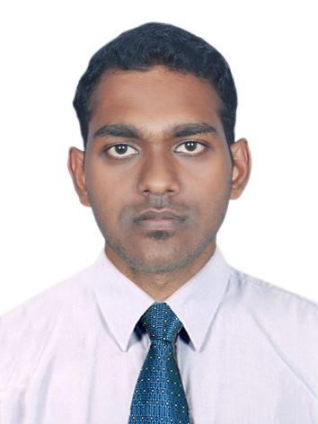
jim

Email: jim.387417@2freemail.com

OBJECTIVE
I wish to seek a challenging position in a growth-oriented organization, where I can explore my professional skills with a distinct image and learning potential.

WORK EXPERIENCE
rooster traders INDIA- Accountant ( from September 9, 2015 to November 30, 2018)
DUTIES AND RESPONSIBILITIES
- Maintaining daily transactions of the company.
- Preparing MIS reports for the Director board.
- Payment follow up.
- Billing
- Filing of GST Tax returns

ACCADAMIC QUALIFICATION
- JAI BHARATH COLLEGE OF ENGINEERING AND TECHNOLOGY, PERUMBAVOOR, KERALA
- Class/ Course : B.Tech(ECE) Year of Passing : 2015
- University : MG University, Kottayam

- GOVT. HIGHER SECONDARY SCHOOL, EDATHALA
- Class/ Course : 12th Year of Passing : 2011
- University : Kerala State Board

- ST FRANCIS D' ASSISI HIGHER SECONDARY SCHOOL, ASOKAPURAM, ALUVA
- Class/ Course : 10th Year of Passing : 2009
- University : CBSE

TECHNICAL SKILLS
- Operating Systems. : Windows XP, Vista, 7, 8, 8.1,10 and Mac OS.
- Computer applications. : Microsoft Office, Tally ERP 9, Inventory-biz, Matlab, C++, C

PERSONAL DETAILS
Sex : Male
Date of Birth : 29-06-1993
Marital Status : Single
Nationality : Indian
Languages known : English, Malayalam, Hindi & Tamil.

