CURRICULUM VITAE

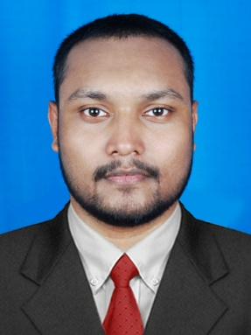

Abdulla Anjillath Kuthurummal
Email: abdullakuthurummal@gmail.com
Phone: 0561563994

SUMMARY
Proficient Mechanic adept at diagnosing, Estimating and Repairing Mechanical and body issues on range of automobiles and light & heavy trucks. Collaborate well and relate easily to diverse colleagues and customers, Resourceful problem solver with strong communication skill

KEY SKILL
- Capable of working on foreign and domestic vehicles.
- Experience of working on diesel engine, Brakes, Suspension, Steering, Pneumatic system and Hydraulic system.
- Experience operating all types of vehicles and Transportation equipment.
- Performing work efficiently and effectively.
- Super Mechanical Aptitude, Manual dexterity and attention to detail.
- Excellent Communication and Co-ordination.
- Flexibility and Adaptability to work in any environment.
- Good team player and positive attitude.

EDUCATION
- Certificate of TECHNICAL EDUCATION AUTOMOBILE ENGINEERING DIPLOMA, Govt. Polytechnic College, Kalamassery, 2005.
- Completed SSLC Education from MRVHSS. Padne, Kasargod, 2002.

PROFESSIONAL EXPERIENCE
- Worked as TECHNICIAN as “MECHANIC CLASS I” in the Period of 2007 To 2014 In DP WORLD Dubail

- Worked as WORKSHOP FACILITY + MECHANIC as “MECHANIC CLASS I” in the period of 2014-2015 in DP World

• Worked as a MECHANIC ( Diesel ) IN THE PERIOD OF 2017 JANUARY TO 2018 JULY In TANZIFCO COMPANY ( QATAR )

Responsible for performing all assigned vehicle repair and maintenance work in accordance with dealership and factory standards

- Carrying out repairs and replacing damaged parts

- Testing motor vehicles and equipment

- Diagnosing the causes of any malfunction

- Ordering parts from suppliers

- Carrying out inspection of completed repairs to ensure that the vehicle is safe to be driven

- Pulling parts off vehicles and tagging them for inventory

- Returning a customer’s vehicle to them in a clean condition

- Following a checklist to ensure that all key work has been done

- Checking engine warning lights , air bag system , transmission oil and filters

- Following safety policies and procedures

- Assisting in assembling trucks and heavy equipment

- To pull out engine and transmission from the vehicles and decouple the engine and transmission

- Completing administrative reports on any work performed

- Performing routine oil changes

- Maintaining an organized neat and safe bay

- To find out troubleshoot for pneumatic system and rectify

- To find out troubleshoot for hydraulic steering system and replace the cylinder kit

- Recoupled the engine and transmission and fitted back the vehicle

- Well experienced in brake system and steering system

- Checking and find out the problems for high pressure water pump

- Clean and lubricate component parts

- Removed and replaced component parts like fan belts , water pump and brake system

- Write up repair orders and provide time and cost estimates

- Worked irregular shifts with emergency after hours call outs

LANGUAGE

- English
- Hindi
- Malayalam
- Tamil

PERSONAL DETAILS:

Gender : Male
Nationality : INDIAN
Father Name : Muhammed Ali UM
Religion : Muslim
Marital Status : Married
Date of Birth : 26-04-1986
Passport Number : L3833454
Expiry Date : 13-07-2023
Visa Status : Visit VISA

Abdulla Anjillath Kuthurummal

