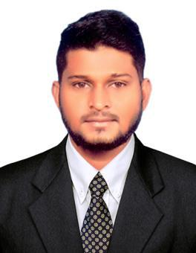
NIYAS
Email: niyas.387439@2freemail.com

Objective

To work in an organization that offers a professional working environment and enables me to enhance my skills and knowledge through challenging work and assignments
______________________________________________________________________________
Summary

- Excellent analytical and problem solving skills, with ability to work independently.

- Fast learner, self motivated, team oriented with a high degree of attention & commitment to work.

- Excellent communication and interpersonal skills.

- Energetic, dynamic and very enthusiastic, creative thinker. Enjoy challenging young minds.

- Forthright and assertive. A friendly, competent and hardworking employee.

- Strong organization and motivational skills.

Work Experience

Organization Location Designation Date

: Peeyesyem Hyundai

: Chennai, India

: Cashier
: 9th July 2018 – Dec 2018

Responsibilities:

- Handle cash, credit or check transactions with customers
- Scan goods and collect payments
- Ensure pricing is correct
- Issue change, receipts, refunds, or tickets

- Redeem stamps and coupons
- Count money in cash drawers at the beginning and end of shifts to ensure that amounts are correct and that there is adequate change

- Make sales referrals, cross-sell products and introduce new ones
- Resolve customer complaints, guide them and provide relevant information
- Bag items carefully
_______________________________________________________________________________

Educational Qualifications

- MBA (HR / Marketing) from Madras University – 2015 - 2017

- B. Com (General) from Madras University – 2012 – 2015

- HSC from State Board - 2012

- SSLC from State Board - 2010

Computer Skills

Operating System known Software known Browsing Known

: Microsoft Window 7.0, 8.0 & 10

: MS Office (Excel, Word, Power Point) & PDF

: I. Explorer, Edge, Google Chrome & Fire Fox

__________________________________________________________________________________
Personal Information

Date of Birth

Religion

Citizenship

Marital Status

: 18-05-1995

: Muslim

: Indian

: Single

: English, Tamil

____________________________________________________________________________________

