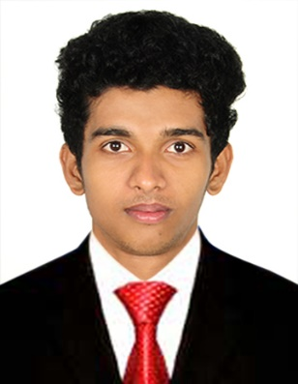
PRESTIN

Email: prestin.387453@2freemail.com

Objective |  | Looking for a challenging career that provides better opportunities for my personal and professional development as well as to contribute to the organization’s effectiveness and productivity in order to take the company to the top position where ever I work.
TECHNICAL SKILLs |  | - AUTODESK INVENTOR  - AUTOCAD  - MS OFFICE
PERSONAL STRENGTH |  | - HONEST AND HARDWORKING  - WILLINGNESS TO LEARN  - DEDICATED TO THE ASSIGNED WORK  - PUNCTUALITY AND LOYALTY TOWARDS TO MY WORK  - GOOD LEADERSHIP QUALITIES
Experience |  | NEEM TRAINEE, TVS SUNDRAM FASTENERS LTD.  NOVEMBER 2017 TO OCTOBER 2018  Sundram fasteners ltd. is a part of TVS group of companies. They have varied range of productions encompasses fasteners, power train components, water pumps, oil pumps and wind energy components.  My duties here included machine operations, quality checking and maintenance of machines.
Education |  | NIRMALA COLLEGE OF ENGINEERING CHALAKUDY  MECHANICAL ENGINEERING (2013-2017)  CGPA: 7.43  ST SEBASTIAN’S H.S.E GOTHURUTH  HIGHER SECONDARY EDUCATION (2010-2012)  PERCENTAGE: 75%  ST JOSEPH’S H.S CHATHEDOM  10TH STANDARD EDUCATION (2009-2010)  PERCENTAGE: 89%
projects |  | - MINI PROJECT: SOLAR AIR COOLER  Description: Solar air cooler is used to regulate the temperature of air inside a closed room using solar energy as the energy source.  - MAIN PROJECT: SOLAR GEAR BIKE  Description: Solar gear bike is an electrical vehicle powered completely or significantly by direct solar energy. Solar energy is used to power all or part of vehicles propulsion.
INDUSTRIAL VISITS |  | - Industrial visit to Autokast Limited, Cherthala, Alappuzha  - Industrial Visit to Kerala Agro Machinery Corporation Limited, Athani  - Wonderla, Banglore - Inspection
OTHER ACHIEVEMENT |  | - Attended Kerala Technological Congress (KETCON 2017), a National conference Jointly organized by APJ Abdul Kalam University and Kerala State Council for Science, Technology and Environment (KCSTE) held at Mar Athanasius College of Engineering, Kothamangalam on 13.1.2017 to 14.1.2017  - Attended National Level Techno-Managerial Cultural fest, CONJURA’17, at T.K.M College of Engineering, Kollam from 16.3.2017 to 19.3.2017  - Published journal on International Journal of Advanced Engineering and Global Technology I Vol-05, Issue-03, May 2017 on topic “Solar Electric Gear Bike” ( http://ijaegt.com/wp-content/uploads/2017/04/609981-pp-1748-1750-Sreejith-1.pdf )  - My project “SOLAR ELECTRIC GEAR BIKE “ got an award of best project in the event “ Techlon 2K17” a project competition conducted as a part of IEDC at Nirmala College of Engineering, Chalakudy on 28.2.2017  - Successfully completed internship program conducted by KELTRON from a period of 17.12.2016 to 23.12.2016
PERSONAL INFORMATION  GENDER :  DATE OF BIRTH :  NATIONALITY :  LANGUAGES KNOWN : |  | MALE  23/03/1995  INDIAN  ENGLISH, HINDI, MALAYALAM, TAMIL

