CURRICULUM VITAE
Name: JALEEL 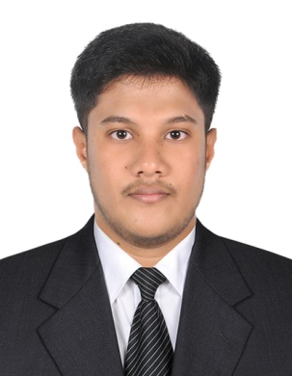
Email: jaleel.387455@2freemail.com

OBJECTIVE

To be a part of an organization where I can fully utilize my skills and make a significant contribution to the success of the employer and at the same time my individual growth.

EDUCATIONAL QUALIFICATION
2013 - 2017 | Bachelor of Engineering in Mechanical |  |  |  | CGPA(6.2)  62.4%
 | St .Joseph’s college of engg and tech, Thanjavur.
 | Anna University, Chennai.
2013 | H.S.C |  |  | (58.1%)
 | S. I. (B. M. S) Higher Secondary School
 | Valuthoor, Thanjavur District.
2011 | S. S. L. C |  |  | (56.2%)
 | P.A. Matric Higher Secondary School
 | Papanasam, Thanjavur District

SKILLS
 | Applications | : | Auto CAD, Solid Work, ANSYS
 | Operating System | : | MS-DOS, Win XP, Windows 7, 8, 10.
 | Packages | : | MS-Office.

TRAINING UNDERGONE
Company Name | : | LUCAS-TVS LTD, Chennai.
Department | : | Maintenance /Assembling of automotive Parts
Designation | : | Graduate Engineer Trainee
Duration | : | 20.03.18 to 29.09.18
ACADEMIC MAIN PROJECT

PROJECT TITLE: Stability analysis of multi walled carbon nanotube (water as base fluid) in 4-stroke IC engine.

DESCRIPTION:

- Served as leader of 4-person group to find out best alternative coolant for the IC
engine in low cost.

- It also improves the overall efficiency and decrease specific fuel consumption of
IC engine.

- To study about the MWCNTs. Successfully construct the model and operate to get
performance reading.

ACADEMIC MINI PROJECT

PROJECT TITLE: Design and fabrication of bearing puller using hydraulic jack.

DESCRIPTION:

- Served as coordinator of 4 members group.

- The main objective of this project is to minimize the manual work while handling
the very expensive components in industry.

- This design of kit coming under the category of special working equipment.

CO- CURRICULAR ACTIVITES

- NDT Workshop Conducted by Prim Institute of Technology in St. Joseph’s College Of Engg & Tech, Tanjore.

- Robotics Workshop Conducted by International Science Research Organization, Tanjore.

EXTRA CURRICULAR ACTIVITES

- Badminton, Cricket

- Reading books and news papers

AREA OF INTEREST

- Production
- Quality control
- Installation
- Maintenance

STRENGTH

- Easily adaptable to work atmosphere, cohesive approach with team members to
produce the best.

- Excellent written and oral communication skills.

- Good Knowledge in automobile and Manufacturing concepts.

- Highly analytical, interpersonal and leadership skills

LINGUISTIC EFFICIENCY

 | English | : | Read, Write and Speak.
 | Tamil | : | Read, Write and Speak.
PERSONAL PROFILE
 | Date of Birth | : | 23rd February 1995
 | Gender | : | Male
 | Nationality | : | Indian
 | Religion | : | Islam
 | Marital Status | : | Single

JALEEL

