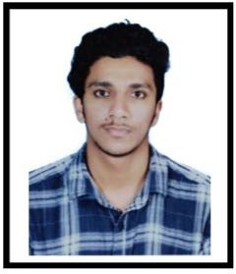
ASLAM

Email: aslam.387468@2freemail.com

A determined, creative, hardworking and confident.

Education

Kannur University - Batch 2018
Btech in Civil Engineering

Skills

Good Communication Skills Problem Solving Skill Dynamic, adaptable, committed, reliable & confident
Hard Working Individual AutoCAD, MATLAB, Staadpro. REVIT ARCHITECTURE

Interests
Learning Languages Cricket
Swimming Photography Travelling
Solving Rubik’s cube

CAREER GOAL

To join an organization that gives me an opportunity to showcase my skills and also helps me gain practical exposure in civil engineering field.

WORK EXPERIENCE

ARCHWELL CONSTRUCTION,KANNUR ASST. ENGINEER
JUNE 2018-DECEMBER 2018

RESPOSIBILITIES

Drafting in AUTOCAD and REVIT Estimation of buildings
Site supervising

Area Of Interest
Innovative construction techniques. Quantity Surveying

PERSONAL DATA
Key Strengths

DOB:
27/01/1996
Logical thinking, good grasping power,

Marital Status: Nationalaity:
Single
Indian
co-ordination & teamwork.
Willingness to learn innovative methods and techniques.

Languages Known
English, Hindi and Malayalam (Speak, Read & Write).
Arabic (Read & Write).
Knowledge of management and
organizational skills, comfortable with authority and responsibility.
Self-motivated individual with creative thinking capabilities and flair for taking initiatives.

TRAININGS

Estimation of buildings under Kolayad Grama Panchayat from 13/12/2017 to 18/12/2017 which is a part of Kerala Life Mission.
Industrial visit at L&T Kochi Metro Rail Site on 29/07/2016.

PROJECT

Mini project

Experimental study of replacing fine aggregate by dredged material in concrete construction.
Dredged materials are soil or excavated material with different parts of mineral and organic properties.

Main project

Experimental study of partial replacement of coarse aggregate by soft drink bottle caps.

