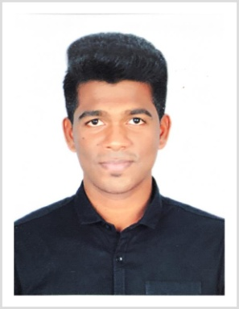
Seelan

Email: seelan.387507@2freemail.com

Summary:

Experienced Assistant Manager with a demonstrated history of over a year in the banking indus-try. Skilled in Negotiation, Operations Management, Sales reports, Customer Relationship Man-agement (CRM) and after Sales Customer Service Operations.

Work Experience:

Experienced as Assistant Manager (Feb 2018 to Oct 2018) in Equitas Small Finance Bank, where my key responsibilities are mentioned below:

- Playing a vital role in assisting the branch with the customer inquiries by their needs and related guidance in the absence of Manager.

- Handling complaints callbacks in Malayalam, Tamil, English and other regional lan-guages and analyse the need of the customers with a focus towards better customer ser-vice.

- Lead a team of 07 Sales Officers to achieve account openings in savings and current, deepening of values in the sourced accounts and offering Life insurance across thousands of customers.

- Effectively liaise with superiors, direct reports and sales MIS using advanced Oracle CRM database within the business unit to achieve business targets.

- Strong checking on authenticity of the KYC documents , AML and recommend for ac-count opening.

Experienced as a Sales Manager on a Contract (Apr 2016 to Dec 2017) at Acre Group Pvt Ltd, at Kanyakumari, India. Where my key responsibilities are mentioned below
- Assist in developing a project mobilisation plan.

- Follow up new business opportunities and setting up meetings.

- Research and develop strategies and plans which identify marketing opportunities, direct marketing and new project development.
- Communicating new product developments to prospective clients

- Actively seek out ways to improve company’s process.

- Lead and train other members of the account team and provide management with feed-backs.

Academics:

Bachelor of Engineering in Aeronautics, 2015, at Sathyabama University, Chennai with a GPA score of 4/5.
Financial and Sales Exposure:
- Loans, SIP mutual funds and Life Insurance.

- Accounts openings, KYC and AML.

- Proven retentions and marketing skills.

- Expert in Microsoft Office suite and troubleshooting issues related to basic IT.

Academic Engineering Project:

Design and Optimisation of Aircraft Structural Wing (Nov 2014- Jan 2015) – SIST University, India

Certifications:

- Certified in advanced Business English Certification examination issued by Cam-bridge University, UK.

- Received various awards on selling life insurance and sourcing account openings by exceeding targets in consecutive months in Equitas Small Finance Bank, Nagercoil.

- Awarded for selling housing plots by increasing company’s portfolios to success.

- Underwent ‘Workshop on Computational Fluid Dynamics’ steered by Professors of IIT at Sathyabama University, 2014.
- Presented the Seminar on Development of Design on Aircrafts.

Personal Information:
D.O.B | : 30-10-1993
Nationality | : | Indian.
Marital Status | : | Single.
Languages Known | :English, Tamil, Malayalam and Sinhalese Tamil

