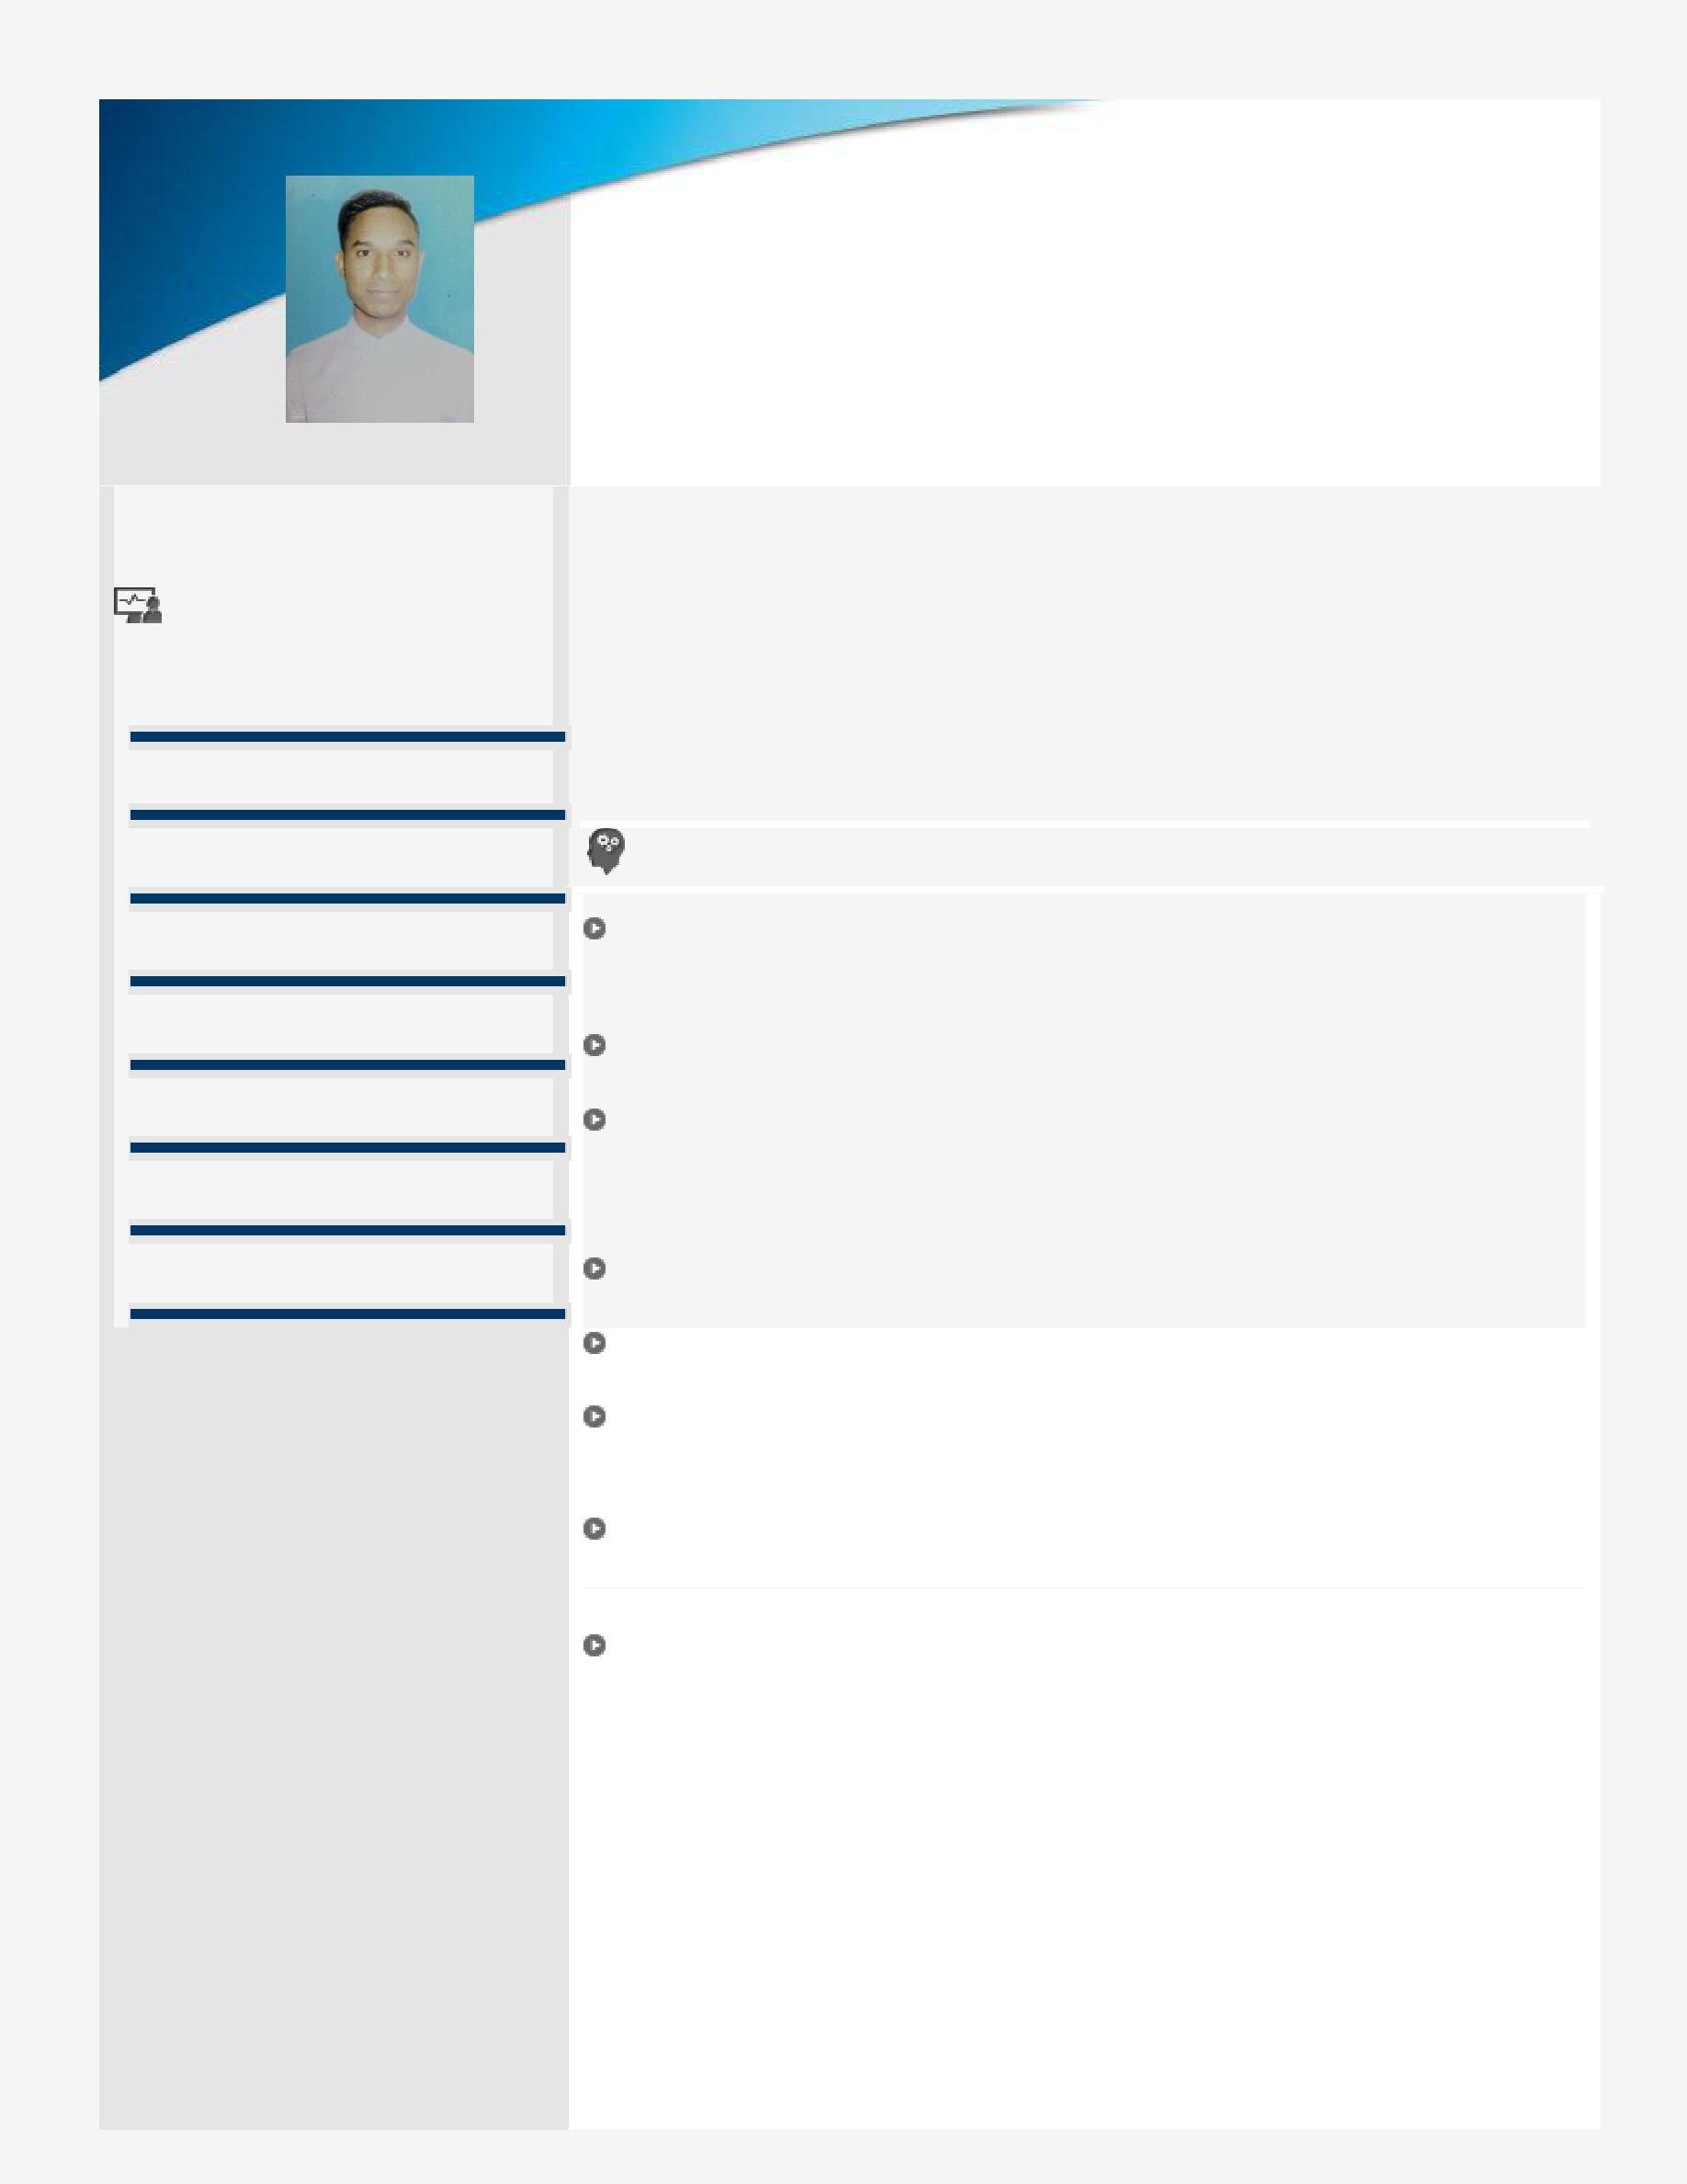
IMRAN CHOUHAN

 |  |  |  | Email ID: imranchouhan606@gmail.com | Contact No.: +971522800918
 | Core Competencies |  |  | B.Tech. (Mechanical Engineering) professional with over 3 year of experience in
 |  |  |  | Manufacturing of Refrigeration Equipments and Production industry; targeting
 |  |  |  | assignments in Mechanical and Refrigeration Engineering with an organization
 | Mechanical Engineering
 |  |  |  | of high repute, preferably in Mechanical industry
 | Manufacturing |  |  | Location Preference: Anywhere in UAE
 | Production |  |  | Profile Summary
 | Client Relationship Management |  |  | Last associated with GNG Enterprises, | Jaipur as Site Supervisor thereby
 |  |  |  | engaged in Investigate equipment failures and difficulties to diagnose faulty
 | Project Execution |  |  | operation and to make recommendations to maintenance crew.
 |  |  |  | Confer with engineers and other personnel to implement operating procedures,
 | Quality Control & Assurance |  |  | resolve system malfunctions, and provide technical information
 |  |  |  | Acquired knowledge of Mechanical Areas which includes Manufacturing,
 | Mechanical Operations |  |  | Production at large scale as well as small scale, Design of Mechanical
 |  |  |  | Elements, Refrigeration Equipments, CNC Machines, Hydraulic Machines,
 |  |  |  | Various Non Destructive Testing Methods, IC Engines and many more
 | Reporting & Documentation |  |  | Comprehensive knowledge of managing projects, with a proven track record of
 |  |  |  | executing Mechanical Projects
Resourceful in on-site activities to ensure completion of project within the set parameters and delivering the project to the client on time

Skilled in planning, executing and spearheading projects involving design coordination, value engineering, quality assurance/control, and resource planning

Research and analyze customer design proposals, specifications, manuals and other date to evaluate the feasibility, cost and maintenance requirements of designs or applications.

Excellent relationship management, analytical and negotiation skills with skills in swiftly ramping up projects in coordination with clients, contractors, vendors and consultants

Soft Skills | Education Timeline
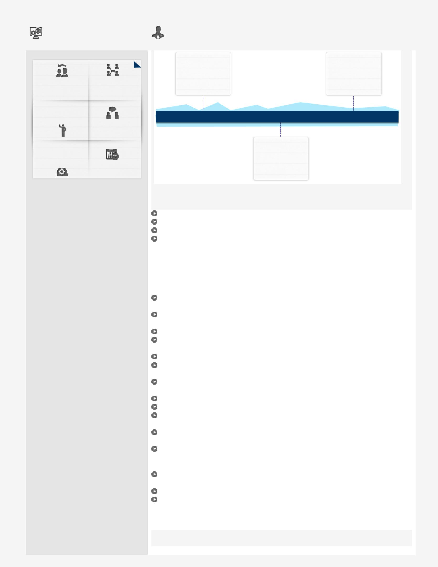

Negotiation Collaborator

Communicator

Team Player

Planner

IT Skills

Work Experience

Education

Personal Details

10th from |  | B.Tech.
Rajasthan Board of |  | (Mechanical
Secondary |  | Engineering)
Education (RBSE), |  | from Rajasthan
Rajasthan |  | Technical
 |  | University, Kota
2009 | 2011 | 2015
 | 12th from
 | Rajasthan Board
 | of Secondary
 | Education (RBSE),
 | Rajasthan
AutoCAD
3d Max
CNC Simulation
Microsoft Office tools

July’15-October’18

GNG Enterprises, Jaipur as Site Supervisor

Key Result Areas:

Designed and prepared an audit report for RO which is belongs to IOCL (Indian Oil Corporation Limited).

Read out the parameters of each earth-pit which are connected by DU machines and storage tank

Assist in the installation of MEP work
Interfaced with the Process Engineers and engaged in following up, evaluating, presenting reports on trial materials according to designated schedules Analyzed mechanical requirements to determine feasibility of design

Conducted mechanical design in AutoCAD, and worked in word processing, adobe, project scheduling, and spreadsheet

Anchored activities to ensure completion of project within the time & cost parameters
Assist in the testing and commissioning of MEP equipment
Ensure that MEP Subcontractors adheres to Project safety regulations.

Ensure that MEP Subcontractors provides and adheres to relevant Quality documentation/records

Coordination and administration of MEP related materials, systems and shop drawings submittals

Direct, monitor and control the activities of MEP Subcontractor

B.Tech. (Mechanical Engineering) from Rajasthan Technical University, Kota in 2015

12th from Rajasthan Board of Secondary Education (RBSE), Rajasthan in 2011

10th from Rajasthan Board of Secondary Education (RBSE), Rajasthan in 2009

Date of Birth: 09 May 1992 || Languages Known: English, Hindi & Urdu

Address: Al Manakh, Sharjah, UAE || Nationality: Indian || Marital Status:

Unmarried || No. of Dependents: 0 || Passport No.: N8613434 || Visa Status: Visit

(Valid Till March’2019) || Driving Licence No.: No

