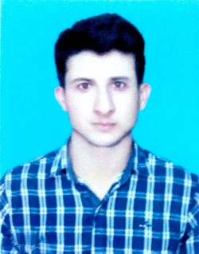
REHMAN

email: rehman.387513@2freemail.com

OBJECTIVE

My Objective is to work in an organization as an integral part of it and accomplish the job assigned in a better way. I’m looking for a highly challenging and dynamic work environment in which I will be able to enhance my professional skills and would be able to get valuable work experience.

EDUCATIONAL QUALIFICATION:

- Bachelor of Electrical Engineering from University of Engineering and Technology, Texila (Pakistan) in January 2018 (GPA: 3)

- F.Sc (pre-Engineering) from Board of Intermediate and Secondary Education Rawalpindi (Pakistan) (Grade-A)

- Secondary School Certificate from Board of intermediate and Secondary Education Rawalpindi (Pakistan) (Grade-A)

SKILLS:
IT Skills: Microsoft Office, Windows, Power Point, Microsoft Excel, AutoCAD, MATLAB, C++(basic), Proteus (Simulation and PCB designing), Arduino.

Other Skills: Teamwork, Communication, Adaptability, Motivation, Persuasions, Punctuality, Flexibility, Fast Learner,

PERSONAL INFORMATION

Name: Khaliq Ur Rehman
Date of Birth 14 Nov. 1992
Marital Status Single
Languages Known English & Urdu
Religion Islam
Nationality Pakistani

INTERNSHIPS

Organization: Oil and Gas Development Company Limited (OGDCL PAKISTAN)
From 16 October 2017 to 11 November 2017

Project: Wireline logging

Responsibilities:

- Monitor the outcomes and to update the senior engineers.
- Advising the technical staff to connect/disconnect & Assemble/disassemble the tools.
- Monitoring environmental health safety (EHS) standards.

AREAS OF INTEREST

- Control Engineering
- Power engineering (generation and distribution)
- Micro electronics
- Computer engineering

