SUSHMITHA

Email: sushmitha.387521@2freemail.com

Performance - driven individual with exceptional office management skills and ability to provide high end support service to human resource needs.

AREA OF PROFICIENCY
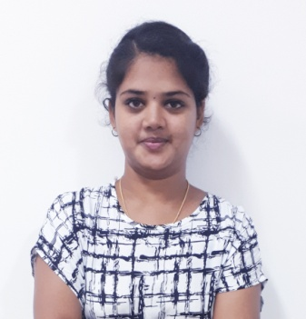
- Update employee records
- Payroll and Compensation
- Teamwork and Collaboration
- Administrative Support

- Filing and data archiving
- Meeting and travel support
- Expenses reporting
- Billing and invoice processing

PROFESSIONAL SYNOPSIS
- HR and admin coordinator at Pandian Surfactants pvt ltd Chennai, India., Duration: 1.2Years (SEPT 2017 TO NOV 2018)
- Professionally qualified with Master of Business Administration (Human Resource and Marketing)

CAREER TRAJECTORY
RESPONSIBILITIES UNDERTAKEN

- Assist with all internal and external HR related inquiries or requests.
- Maintain both hard and digital copies of employees' records.
- Perform orientations and update records of new staff.
- Produce and submit reports on general HR activity.
- Assisting with the performance review and termination processes
- Assisting with the recruitment and interview processes
- Greeting and directing visitors to the appropriate parties.
- Handling basic office duties, such as answering and routing phones, responding to emails, maintaining employee, financial, and client records, and data entry and reporting.

- Answering questions and finding information for employees, vendors, clients, and lenders.
- Supporting employees by facilitating interdepartmental communications and interactions between internal and external parties.
- Ensuring that the office is well-maintained, organized, and secure.
- Handling dispatch approval and following customer outstanding.
- Collecting and analyzing sales data
- Prepare reports & presentations with statistical data, as designed
- Creating invoice and purchase order
- Creating & maintaining employee files, ensuring leave days, overtime & others are planned and calculated correctly in excel.
- Schedule and Coordinates meetings, appointments and Travel arrangements for supervisors and managers.
- Manage travel and expenses report for department team members.
- Purchased and maintained office supply inventories, and being careful to adhere to budgeting practices.

KEY PROJECTS
Project 1: A Study on employees training and development in an organization in FYNN SOFT, Madurai
Project 2: Kids E-care management, TV SUNDARAM IYENGAR & SONS PVT LTD

KEY SKILLS AND COMPETENCIES

- Ability to multitask and prioritize daily requirements.
- Ability to handle data with confidentiality
- Good organizational and time management skills
- Knowledge of human resources processes and best practices
- Strong Microsoft Office skills.

PERSONAL TRAITS

- Comfortable working in a fast paced, challenging environment.
- Task oriented, analytical and able to produce accurate work results.
- Flexible with a positive “can do” attitude.
- Can coordinate with wide range of activities at any one time

CERTIFIED COURSES

MS- Office &Excel C Program C++Program PHP

ACADEMICS

MBA (HR AND MARKETING) from PSNA College of Engineering and Technology, Dindigul in 2017 with 70 %

B.Sc (CS) from SOURASHTRA College (coed), Madura in 2015 with 70%

PERSONAL DETAILS

Date of Birth: 25.10.1994

Marital Status: Single Nationality: Indian

Languages Known: English, Tamil, and Sourashtra

`

