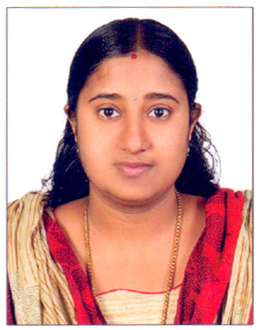
RESUME

RAHITHA

Email: rahitha.387522@2freemail.com

Career objective
To have a challenging and rewarding career to produce time bound excellent results and also be associated with a progressive organization that would give me a position to utilize my skill and abilities being resourceful and innovative.
Educational Qualification

Qualification | Board/University | Year of passing | Percentage of marks
MSc. Computer science | Kannur university, Kerala | Result waiting
BSc. Computer science | Kannur university, Kerala | 2014 | 66.5%
Higher secondary | Board of Kerala | 2011 | 70.5%
Matriculation | Board of Kerala | 2009

TECHNICAL QUALIFICATIONS

- Programming Languages : C, C++, Java, C#,.Net,
- Operating System : Windows 8, Xp & 7
- Database System : Microsoft sql server-2008, My SQL
- Web Technologies : HTML, JavaScript
- MS Office

Working Experience
- Worked as a Office Assistant in College of commerce, Kannur – Kerala (1Year)

Strong points in myself
- Hardworking towards achieving the goal
- Flexibility in technical area.
Personal Profile

Name | : RAHITHA
Date of birth | : 08/05/1994
Gender | : Female
Nationality | : Indian
Marital status | : Married
Languages known | : English,Hindi & Malayalam

