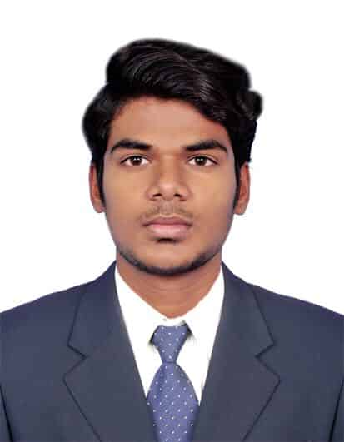
Profile: Noordeen
Email: noordeen.387539@2freemail.com

Objective:
Seeking a challenging position in the field of suitable position that offers further vertical growth in responsibilities, a lateral growth in terms of exposure challenging tasks in a progressive and professionally managed organization.
Key skill sets:
- Sound Knowledge in PLC and SCADA systems. Programming and modifying PLC programming and SCADA designing.
- Project Coordination and Management Professional.
- Sound Knowledge in Database Management of Customers and Suppliers.
- Highly effective in Vendor Management and Negotiation. Knowledge of advanced statistical analyses and ability to apply that knowledge to analyze data or create models.
- A qualified Electronics and Instrumentation Engineering professional with comprehensive knowledge in Project execution of electrical Equipment.
- Sound knowledge of the latest trends and techniques of the field alongside a wide range of skill sets as well as troubleshooting, problem analysis and resolution skills.
- Organized, disciplined and task focused with fine-tuned analytical, troubleshooting and administrative skills.

Academic qualification:
- 2014-2018 B.E (Bachelor of Electronics and InstrumentationEngineering) with 67% from M.A.M Collegeof Engineering(Anna university affiliated) Trichy, TamilNadu.
- 2013-2014 Completed 12th with 89% from Gandhi Matriculation Higher Secondary School, Madukkur.
- 2011-2012 Completed 10th with93%from Gandhi Matriculation Higher Secondary School, Madukkur.
- Part of Schooling in Dubai, UnitedArab Emirates.

Projects& Achievements:
- Health Monitoring Devicefor Human Heart based on Machine learning using Python as a coding Language.
- Separation of biodegradable and non-biodegradable waste management system based on automation using PLC.
- pH measurement and supervisory control of pH neutralization in agricultural irrigation system based on automation using PLC and SCADA.
- Presented a paperon an Automatic Co-OperativeCruiseControl in J.J.COLLEGEOFENGG, TRICHY.
- Presented a paper on GRAPHENE & its characteristics inTAMILNADU ENGINEERING COLLEGE, Coimbatore.

Skills:
- MIS Reporting.
- Touch Typing Skills.
- MS Excel, MS Word, MS PowerPoint

