HUSSEIN

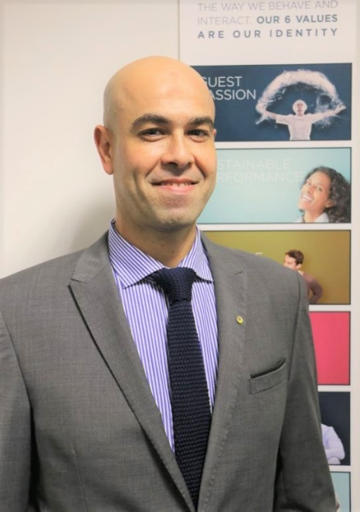

Email: hussein.387566@2freemail.com

Statement
A PRO who has extensive experience and has been granted a wide range of responsibilities in the planning, developing, organizing, evaluating, communicating, and executing strategies to present organizations to the public in a positive manner.
Possesses a strong background in implementing effective channels of communication within organizations.

Education Higher Industrial Technical Institute, Cairo, Egypt 1994-1998
Professional Experience
Cluster Public Relations Officer Current
Novotel, Ibis and Adagio Al Barsha, Dubai, UAE
- Handle processing all types of visas like employment visas, residence visa for staff and also for guest artists and entertainers.
- Handle processing and renewal of permits and licenses which includes the hotel’s Trade License, Liquor Trading License, Certificates of Registration in the Chamber of Commerce, Certificate from Civil Defense, CCTV and Radio Communication.
- Handle and assists all of medical requirements of the employees.
- Handle renewal of Entertainers Permits/N.O.C. through Department of Tourism, PRO Card, Immigration Deposit Boxes, etc.
- Handle and attain permits for advertisement display or signage, publishing, special promotions, etc. as required.
- Responsible for processing and renewal of registration for all the hotel’s transportations.
- Keep track for any update with regards to changes to the laws, rules and regulations, changes in forms; formats, changes in other procedures and relay such changes to the Human Resource Manager.
- Ensuring that relevant documents are submitted regularly to the Labor Office with regards to cancellation/absconding employees and remove from Hotel’s sponsorship list and to complete departure and exit formalities for staff after cancellation of visas.
- Working hand in hand with the Human Resource team and assist HR clerk to ensure that forms and formats for all transactions are written correctly and complete for submission.
- Making a monthly report on visa reconciliation and passport inventory.

Public Relations Officer - PRO 2014-2015
Zepter International, Al Sharja, UAE
- PRO in charge for all governmental relations and documentations.
- Handle processing all types of visas like employment visas, residence visa for staff.
- Working hand in hand with the Human Resource team and assist HR clerk to ensure that forms and formats for all transactions are written correctly and complete for submission.
HR Specialist 2010-2014
Alfam Omega Clothing Factory Cairo, Egypt
- Implement company hr. policy , develop and update if needed
- Responsible employee pay and benefits
- Responsible company government relations
- Responsible recruitment and selection process.
- Maintain company insurance contracts.
- Manage and maintain employees’ records, personnel files, and database.
Purchasing Manager 1999-2010
Delta Textile Egypt, Cairo, Egypt
- Maintain records of goods ordered and received.
- Locate vendors of materials, equipment or supplies, and interview them in order to determine product availability and terms of sales.
- Prepare and process requisitions and purchase orders for supplies and equipment.
- Control purchasing department budgets.
- Interview and hire staff, and oversee staff training. Review purchase order claims and contracts for conformance to company policy.

Language Skills
Arabic (Native Speaker)
English (Very Good)

Technical Skills
MS Office/Immigration platforms

General characteristics
Highly organized, proactive, hardworking, focused, possessing exceptional attention to detail and capable of meeting deadlines swiftly.

