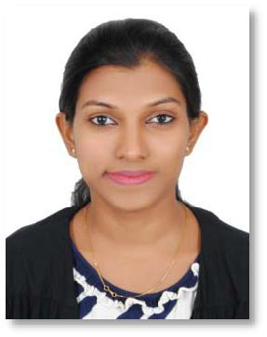
NISHATHA

Email: nishatha.387677@2freemail.com

OBJECTIVE:

To build upon and enhance my professional skills in a reputed and dynamic organization that gives me the opportunity to evolve in a professional manner.

EDUCATION:

B.E in Information Science and Engineering from P.A COLLEGE OF ENGINEERING affiliated to VTU, Belgaum in the year 2015.

WORK EXPERIENCE:

Jonas Petro Products Pvt Ltd, Mangalore (August 2015 – June 2017)

Designation: Admin Co-ordinator

Roles and Responsibilities:

- Responsible for looking after day to day general office administration

- Coordinate with the internal departments for admin related activities

- Handling telephone communications and resolving information requests

- Purchasing and maintenance of general office supplies

- Maintaining files and records for the office and updating data in the departmental database and records

TECHNICAL SKILLS:

- Proficient with MS Word, MS Excel, MS PowerPoint, MS Outlook

- Operating Systems : Windows 8/7/XP

- Database : MySQL

- Languages : C, C++, Java, HTML

WORKSHOPS:

- Linux workshop organized at P.A COLLEGE OF ENGINEERING with course material provided by the Talk to a Teacher project IIT Bombay.
- Undergone soft-skill training conducted by FACE.

- Undergone soft-skill training conducted by i-point.

KEY STRENGTHS:

- Problem Solving Skills
- Creativity
- Self- Motivation
- Flexible
- Quick Learner

Page 1 of 2

PERSONAL PROFILE:
Date of Birth | : 14 March 1993
Gender | : Female
Nationality | : Indian
Marital Status | : Single
Languages known | : English, Hindi, Kannada and Tulu
Hobbies | : Playing badminton, watching movies and reading newspaper

Page 2 of 2

