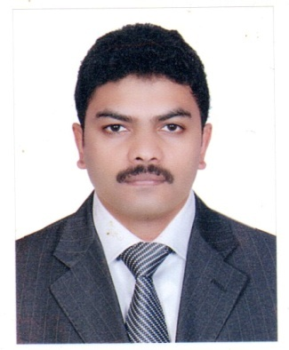
FAISAL
Email : faisal.387722@2freemail.com
OBJECTIVE
- To achieve a senior position in Finance & Accounts with an organization of repute which facilitates professional growth and utilization of my qualifications and experience.
- To work in a more professional and challenging working environment that helps to advance the abilities of financial management and financial analysis
- To contribute accumulated knowledge and experience to business
- To find a stable job with promotion prospects and competitive salary

CORE COMPETENCIES
- Keep financial records accurately.
- Prepare correct and essential financial reports for auditing and higher management.
- Innovative and practical view.
- Capable of taking speedy and exceptional decision and also put thoughts in order in terms of time limit and workload.
- Exceptional communication as well as interpersonal skills.
- Familiar with current computer technology.
- Profound understanding of international finance.
- Capable of setting priorities, managing multiple tasks and meeting up deadlines.
- Exceptional in assessing and interpreting composite financial data

WORK EXPERIENCE
2006 – 2017 Arzanah Group of Companies, Abu Dhabi
More than ten years of experience in Arzanah Group of Companies as Senior Accountant for Arzanah Contracting Est., Arzanah Trading Est. and the health care division Golden Sands Medical Centre and Sands Pharmacy. - Reporting to Managing Director.

Major Responsibilities
Arzanah Contracting Est.
- Performs finalization of accounts, monitoring all entries for purchase, sales, receipt, payments, bank reconciliations etc.
- Manage the team of junior accountants, monitor their performance and provide them instructions whenever necessary.
- Liaising with banks for arranging banking facilities (Term Loan /OD/Letter of Credit /Guarantees) for projects/ general purpose and utilize it in an effective way.
- Preparation of Cash flow statements.
- Preparation of Aged Balance report, analysis and monitoring of Receivables/Payables and the follow up of the same.
- Preparation and follow up of Balance confirmation against various bank accounts, customers and suppliers for the purpose of year ending Audit.
- Preparations of various year ending schedules such as Depreciation schedule, Pre-paid Income, Provision for gratuity, and Provision for Accrued Expenses, Accrued Income etc.
- Preparation of all closing entries for finalization of accounts.
- Providing valuable information to the management whenever necessary for the purpose of managerial decision making.
- Liaise and assist external auditors; implement recommendations if any; take corrective action wherever required.

Arzanah Trading Est.
- Ensure that all petty cash activity is handled in an efficient manner, accurate and timely manner ensuring safe custody of cash at all times.
- Coordination with customers and vendors regarding schedules and payments
- Physical Stock assessment in stipulated time periods.
- Analyzing the variance in the physical stock to system and reporting to the authorities regarding variance.
Golden Sands Medical Centre
- Prepare monthly/ quarterly /annually reports for higher management.
- Analysis of operating expenses and revenue.
- Cash management.
- Payroll Administration.
- Prepare commission reports for doctors, based on income earned by each doctor.
- Ensure General Ledger entries are accurate and are in line with Company Procedures & International Accounting Standards.

Administrative & HR Duties
- Experienced with preparing, executing, and analysis of employee payroll under Wage Protection System
- Co-ordinate with other departments for inter-departmental transactions

EDUCATION
- Certified Management Accountant - Institute of Management Accountants (IMA) - U.S.A
- Bachelor of Commerce - University of Calicut, Kerala, India

PERSONAL INFORMATION
Nationality Indian
Date of Birth 31 May 1981
Languages English, Hindi, Arabic & Malayalam

COMPUTER SKILLS
MS OFFICE SOFTWARE Word, Excel, Power Point etc..
ACCOUNTING SOFTWARE Tally, Peach Tree.
ERP SYSTEM SAP

