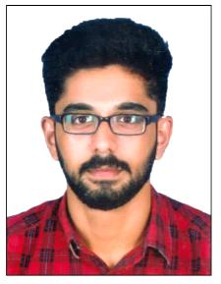
BENNET
Email: bennet.387725@2freemail.com
PROFESSIONAL SUMMARY
Hardworking and sincere individual with a pleasant personality. Dedicated to enhance department operations with an analytical and disciplined approach. Able to work with minimal direction to solve problems, resolve conflicts and respond to customer inquiries. I have 1 year experience as Officer/Admin position.
SKILLS

- Preparation of Financial Statements
- Interpersonal and written communication
- Data entry
- Hard working
- Adaptable and Flexible

- Quick learner
- Helping Mentality
- Team player
- MS office-Word, Excel, Power Point
- Tally ERP 9.0

WORK HISTORY
- OFFICER [05/06/2017 - 22/09/2018]
Rachana Flex and Digital Designs – Ranni-Kerala, India
      - Daily reconciliation of cash and Account Statement.
      - Analysis and Preparation of Financial Statements.
      - Maintained friendly and professional customer interactions.
      - Maintained daily cash transactions.
EDUCATION
2017 Master of Business Administration: Finance
Post Graduate Programme in Management (PGPM)
Amity Global Business School – Cochin- Kerala, India
2015 Bachelor’s Degree: Commerce with Computer Applications
Girideepam Institute of Advanced Learning – Kottayam-Kerala, India
PROJECTS AND ACHIEVEMENTS
- Project on Consumer Preference In Big Bazaar
- Project on Consumer Behaviour Towards Smart Phones Among Youngsters
- Volunteer in IDBI Spice Coast Marathon in 2016
- Participated in All India Management Fest Luminance in 2014
- Participated in International Assessments for Indian Schools conducted by University of New South Wales Australia in 2011
PERSONAL DETAILS
- Date of birth : 03/10/1994
- Gender : Male
- Nationality : Indian
- Languages known: English, Hindi, Malayalam
- Marital Status : Single

