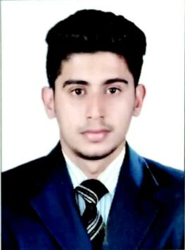
MUHAMMED
MECHANICAL ENGINEER
muhammed_387744@2freemail.com
Visa Status: Visit Visa

CAREER OBJECTIVE
In the present world of Technical evolution, I would like to be a part of an esteemed and prestigious organization, which helps in enhancing my knowledge domain and upsurge my professional career.

PROFESSIONAL EXPERIENCE
Assistant QC Engineer,
Duration: (October 2016 – November 2017)
- Responsible for Quality related work in the site.
- Responsible for incoming material handling including equipment and tools.
- Well conversant with materials of CS, SS and LTCS.
- Review of WPS(Welding Procedure Specification) and PQR(Procedure Qualification Record) and various sub contractors work procedures as per International standards and specifications..
- Inspection of fit-up, root, visuals, final inspections, preheat , post weld heat treatment and inter pass temperature during welding as per the relevant WPS.
- Witnessing in Non Destructive Testing like UT, MPT, LPT & RT and Visual Inspection, Representing our company in management and technical meeting in project assigned.
- Study of Isometric drawing, General arrangement drawing.
Trainee Mechanical Engineer ( MEP ),
Duration: (March 2018 – May 2018)
- Conduct regular site visit and supervision of construction activities as per approved plans and layout.
- Monitoring site progress and quality of MEP works and compliance.
- Approved shop drawing and installation schedules.
- Co-ordination with MEP sub contractor both at site level and with sub contractors engineers.
- Monitoring and reporting site progress and compliance with specification.
- Preparation of daily and monthly progress reports for management review.
- Maintaining detailed site records for changes and progress of Construction work.
- Cost estimation and analysis of site construction materials and activities.

ACADEMIC QUALIFICATIONS
- BE/B.Tech in Mechanical Engineering from Excel College of Engineering & Technology, ANNA University, Chennai, with 7.2 CGPA in 2016.
- 12th from St N.H.S.S., Karayogam, Kottakkal, Kerala with 82% in 2012

PROJECTS HANDLED
- Private Villas in Nad Al Sheba.(MEP)
- Reliance J3 Project, Jamnagar

CERTIFICATES
- NDT Level II
- QC Welding - AWS Certification
- Piping - TUV Rheinland Certification
- AutoCAD

SOFTWARE SKILLS
AutoCAD, MS Office, Drafting

ACHIEVEMENTS & LEADERSHIP SKILLS
- Coordinator of Technical events GENESIS 2K16
- Certification of Practical Training on Cars & Engines.
- PG Diploma in Oil and Gas Piping
- Played Football at Zonal Level.
- Undergone short term course in QC Welding.

PERSONAL INFORMATION
D.O.B : 20/07/1994
Sex : Male
Marital Status : Single
Nationality : Indian
Languages Known : English, Malayalam, Tamil and Hindi

