BRIJESH
MECHANICAL ENGINEER

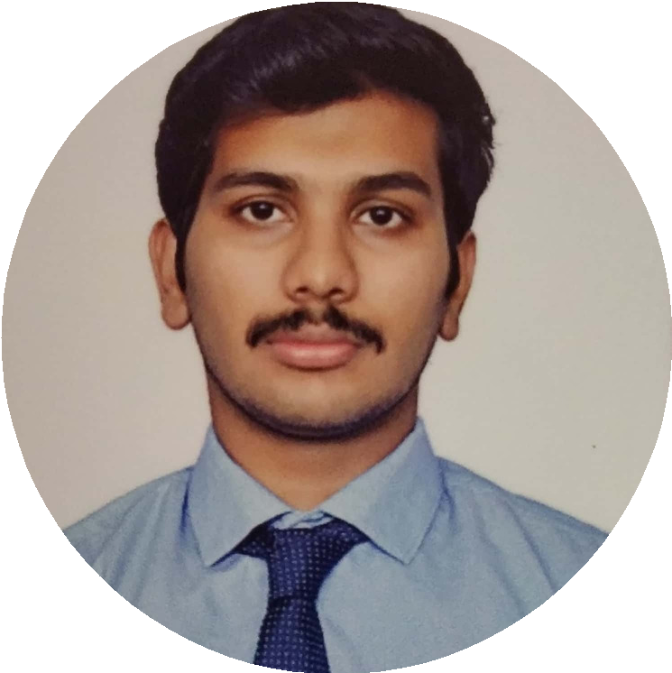

INTRODUCTION
I am Brijesh. a highly motivated and dedicated mechanical engineer with good professional knowledge yearning to solve the real life problems in the organization, expand my company, satisfy the company's as well as my goals considering the people welfare and to enhance my professional skills in dynamic and fast paced workplace.

TECHNICAL SKILLS

Computer Aided Design Drafting Standards and GD&T Mechanical Skills
Oversee Manufacturing Process
Read and Interprete Drawing and specs. Sound Knowledge of Engineering Basics Procurement and Purchasing

CERTIFICATION
PROFESSIONAL IN PRODUCT DESIGN AND ANALYSIS

Email: Brijesh_387755@2freemail.com
+

IT SKILLS

AutoCAD SolidWorks Creo Parametric Ansys
Microsoft Office Suite Google Analytics Documentation

EDUCATION

BACHELOR OF ENGINEERING - MECHANICAL ENGINEERING

SRI SAIRAM ENGINEERING COLLEGE, ANNA UNIVERSITY (CHENNAI, INDIA)

Graduated in 2017 with a CGPA of 8.47 Completed the degree with no history of backlogs.
Gained good knowledge of the mechanical core subjects and hands-on experience in the laboratories
Successfully accomplished the Final year project and Pre-final year Project well ahead of the prescribed time.

HIGHER SECONDARY

SHRI KRISHNASWAMY MATRIC.HR.SEC.SCHOOL (CHENNAI, INDIA)

Completed in March 2013 with 95.58% Major Subjects - Physics, Chemistry, Maths

SSLC

SHRI KRISHNASWAMY MATRIC.HR.SEC.SCHOOL (CHENNAI, INDIA)

Passed in April 2011 with 96.0% Major Subjects-Science, Maths

CAREER EXPERIENCE
Position : Design and Procurement Engineer OCT 2017-JULY 2018

Client : Gem Sugars Limited
Nature of Work : Design and Installation of Fire Protection Equipments Client : Tamilnadu Newsprint and Papers Limited (TNPL)
Nature of Work : Design and Installation of Fire protection Equipments

KEY RESPONSIBILITIES
Inspecting the architectural design and plan of the building.
Calculating all project area dimensions for drawing and layout preparation.
Planning the type of fire protection system required according to the kind of industry . Developing the pipeline layout design and CAD drawings.
Analysing the pipeline diameter, pressure required at the pipe ends, grade of pipe required and variant of suitable pump.
Coordinating with team members and detailing them about the system layout. Informing clients of all the project specifications and the system design.

REFERENCES
Available upon Request
HOBBIES

Playing Cricket and Football Listening to music
Reading Novels
Travelling
LANGUAGES KNOWN
English Hindi Malayalam Tamil French
PROFESSIONAL SKILLS

Logical Thinking Problem Solving Creativity
Good Communication skill Teamwork
Interpersonal skills
Positive Attitude
ACADEMIC PROJECTS

Electric Pulse Magnetic Braking System
Design and Fabrication of Cylindrical
Die using EN08 Steel

After the approval of the client, calculating the quantity of the raw materails needed to accomplish the project.
Negotiating with the vendors, ordering and purchasing the equipments such as pipes, valves, pumps etc.
Inspecting the incoming raw materials and consumables and completing the commissioning activities of the project.

TRAINING & INTERNSHIPS
Completed 2 months of internship in the Research and Development team of Ashok Leyland Private Limited, Chennai.
Completed training in Gamesa Wind Turbines Private Limited,Chennai. Underwent industrial visits to Neyveli Lignite Limited, Integral Coach Factory and Lucas TVS Limited.
Attended National workshop on "Computational Fluid Dynamics in BITS-PILANI Hyderabad,India.

EXTRA CURRICULAR ACTIVITIES
An active NSS member and Student Execute council Member in SAE India.
Conducted a computer training program "Reaching the Unreached" in the Municipal Middle School, Chennai.
Organized "Healthy youth for healthy India at Perumbakkam village for 1 week and Blood donation camp under Madras Voluntary Blood Bureau.
Received the Best Outgoing Student of the school award for the academic year 2013-14.
Co-ordinator and Functional Head for the event "Material Identification" in TIER 1 SAE Student Convention 2016.

PERSONAL DETAILS
Date of Birth : 29-12-1995 Gender : Male
Religion : Hindu
Marital Status : Single Visa Status : Visit Visa Nationality : Indian

