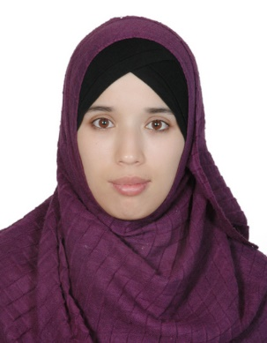
Dr. Nigora

Personal Details
Email : nigora_387788@2freemail.com

Job Objective
To use my skills and abilities to obtain a position within an organization as a General Practitioner in my chosen field.

Professional Summary
Accomplished general practitioner with 3 years of experience in the medical field. Highly skilled in diagnosing and treating a variety of human diseases and injuries. Exceptional understanding of drug properties and interactions, procedural techniques, and preventative health-care methods. Extraordinary decision-making skills and critical thinking capabilities.

Skills
– Excellent critical thinking and problem-solving skills when identifying the best treatment option for various injuries and ailments. – Superior reading comprehension skills and effective written and oral communication skills. – In-depth knowledge of procedures for diagnosing and treating patients. – Understanding of mental and physical rehabilitation methods and counseling approaches. – Exceptional interpersonal skills and personable bedside manner. – Ability to plainly explain physical problems as well as treatment solutions so patients have a clear understanding of what is happening to their bodies and how treatment can help them. – Outstanding perception skills that allow me to sense the emotions of my patients and help them feel at ease.

Work Experience
August 2013 – November 2016
- Administer treatment, medication, therapy, vaccinations, and other medical care to treat patient diseases, injuries, and illnesses.
- Prescribe medication or specialized care to meet specific patient needs.
- Monitor the progress and current condition of patients to determine whether current treatments are working or if modifications are needed.
- Collect patient information (including examination results, medical history, and other reports). Record information in electronic filing systems.
- Explain test results and recommended procedures to patients.
- Answer patient questions and use active listening skills to understand and address concerns.
- Provide emotional support and medical attention to others as needed, including patients, customers, and coworkers.
- Analyze images or test data to make diagnoses and develop treatment plans.
Education

2006 to 2013 Bachelor Degree in the specialty of General Practitioner,
Tashkent Medical Academy, Uzbekistan
(University Hospital, studying and clinical practice)

1995 to 2006 High School№6 Tashkent, Uzbekistan

Knowledge

Language : | - Uzbek – native.  - Russian - Very good knowledge.  - English - Very good knowledge.  - Arabic - Basic
IT Knowledge : | - Windows;  - Microsoft Word, Excel;  - Internet Explorer.
Hobbies and Interests

- Cooking
- Reading
- Travel
- Learning languages

License

DHA Eligibility Letter Issued on 27th March 2018

