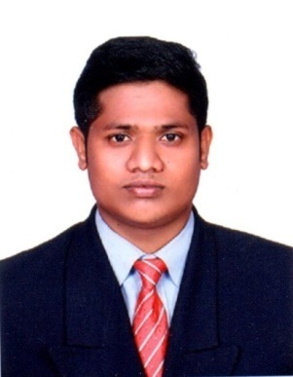  E-Mail: Praveen.387825@2freemail.com  Personal profile:  Date of Birth : 01/08/1994  Gender : Male  Nationality : Indian  Marital Status: Single  Language Known:  English,  Tamil,  Malayalam | PRAVEEN  Objective  To serve the organization with constant spirit, motivation, while also taking up interesting and innovative tasks that places my career in the path of growth in the organization.  Work Experience  Company Name : Worldwide Logistics (INDIA) pvt Ltd  Designation : Jr Executive – Air Export  Period : 12 October’2017 to 03 December’2018  - Planning the Shipment as per the Quotations and Destinations.  - Obtaining the approvals from destination office for the each and every shipment along with the rates.  - Execution of MAWB’s & HAWB’s  - Preparing the documents along with the Cargo Transfer Manifest.  - Pre alerts to customers and Destinations.  - Co-ordination with CHA for the Customs Clearance  - Co-ordination with Sub-Agent for origin Clearance  - Updating the reports DSR.  - Updating of the cargo details in particular applications in online and software’s.  - Follow up the shipments through tracking and update to agent  Academic Record  MBA (2017)  University : Bharathiyar University  Discipline Campus : Integerated Multimodal Logistics Management : St.Britto’s College, Chennai, India
Hobbies :  - Fishing  - Swimming  Strengths:  - Courage  - Confidence  - Working well in a group | B.Com (2015)  University : Manonmaniyam Sundaranaar University  Discipline : Corporate Secretaryship  Campus : St. Xavier’s College Of Arts And Science. Tirunelveli, India  Higher Secondary School Education (2012)  Board : State Board Of Secondary Education  Discipline : Course with Commerce  Campus : Pius XI Hr. Sec School Thoothoor Kannyakumari, Tamilnadu India.  Secondary School Education (2010)  Board : State Board Of Tamilnadu Education  Campus : Central Hr. Sec School kayalpatnam Tuticorin, Tamil nadu India..  TECHNICAL SKILLS  - MICROSOFT OFFICE

