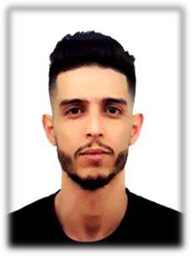

Khalfi

Date of birth

21-12-1992

Social status

Single

E-mail

Khalfi.387836@2freemail.com

Driving Licence Category (B)

Education

March 2016

Diploma in television’s professions ( presenter and animator tv ).

June 2015
Training report veiling in football stadiums.

June 2015
Bachelor degree in Sciences of Media and Telecomminication .
Faculty : Human and Social Sciences.
Departement : Human Sciences.
University of Djillali liabes Sidi bel abbes – Algeria.

June 2011
Baccalaureate , Field: Foreign languages , Good

Work Experiences

Salses and marketing in company HASNAOUI GROUPE .janury - September 2018

Salseman and marketing at cosmetics product in company ETS BEN KHALIFA COSMETICS .febrery – november 2017

Salseman at Sephora house .march – décember 2016

Languages

• | Arabic | Very Good ( fluently)
• | French | Very Good
• | English | Good

Computer Skills

• Windows Very Good

• Office(Word, Powerpoint,Exel,…) Very Good

Skills

- Dynamic

- Punctual

- Abte to work in group ( Easy to adapt )

- Creative

- Possibility to work for extra hours

Responsibilities

✓Present, promote and sell products/services using solid arguments to existing and prospective customers

✓Perform cost-benefit and needs analysis of existing/potential customers to meet their needs

✓Establish, develop and maintain positive business and customer relationships
✓Reach out to customer leads through cold calling

- Expedite the resolution of customer problems and complaints to maximize satisfaction
✓Achieve agreed upon sales targets and outcomes within schedule

✓Coordinate sales effort with team members and other departments

✓Analyze the territory/market’s potential, track sales and status reports

✓Supply management with reports on customer needs, problems, interests, competitive activities, and potential for new products and services.
- Keep abreast of best practices and promotional trends

- Continuously improve through feedback

